UNCORRELATED ORBITAL TRACK PROCESSING
Final Design Document
Kyle Galang, Aurela Broqi, Ruben Dennis, Aaron Nogues, Ezra Stone

COP4934: Computer Science Senior Design I
Dr. Richard Leinecker
University of Central Florida
Orlando, Florida
November 24, 2025

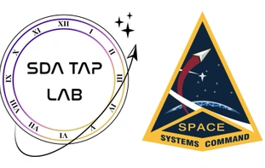


Table of Contents

- Supplementary Material
1.1. Definitions 3-5
1.2. Document Breakdown 6
1.3. Researchers Personal Statements 7
1.3.1. Kyle Galang 8
1.3.2. Aurela Broqi 9
1.3.3. Ruben Dennis 10
1.3.4. Aaron Nogues 11
1.3.5. Ezra Stone 12-13
- Project Concept of Operations
2.1. Executive Summary 14
2.2. Problem Statement 15
2.3. Design Plan 16
2.4. Minimum Viable Product 17
2.5. Timeline and Milestones 18
- Uncorrelated Track Processor
3.1 Introduction
3.1.1. UCTP workflow and code
3.2 Dataset Generation Workflow
3.2.1. Data Shaping
3.3 Evaluation Workflow
3.3.1. Orbit Association Metrics
3.3.2. State Metrics
3.3.3. Residual Metrics
3.3.4. Binary Classification Metrics
3.3.5. Processor and Outputs
3.3.6. Conclusion
3.4 Definitions of Dataset
3.5 Unified Data Library
3.6 Conclusions
- OpenEvolve Framework
4.1. Introduction
4.2. OpenEvolve Basic Functionality & Process
4.3. UCTP Integration to OpenEvolve
- Symbolic Regression
5.1. Introduction 53-55
5.2. Foundation 56
5.3. Expected Result 57-58
5.4. Hypothesis Generation 58-59
5.5. Sampling and Validation Process 59
5.6. Optimization and Scoring 60-61
5.7. Data Set Generation 61-62
5.8. Testing and Evaluation 63-64
5.9 Nonlinear Oscillator Equations 64
6.0 Noise Robustness Analysis 64-68
6.1 LLM-Based Optimization Baselines 69
6.2 Summary 69-71
- Graphical User-Interface Development (GUI)
6.1. Introduction
6.2. OpenEvolve Architecture Versus Traditional Stacks
6.3. Analytics Console Integration
6.4. Analytic Console Development
6.5. Future Development
6.6. OpenOnDemand
- Large Language Model Development (LLM)
7.1. Introduction
7.2. Purpose of the LLM
7.3. System Architecture
7.4. Model Training and Data
7.5. Evaluation and Benchmarks
7.6. User Experience and Features
7.7. Limitations and Future Work
- GitHub Environment and Documentation
8.1. Overview
8.2. Documentation Finalization Overview
8.3. Research Finalization Overview
8.4. Analytics Console Finalization Overview
8.5. mLLM Finalization Overview

Chapter 1. Supplementary Material

1.1 Definition of Terms
Throughout the document abbreviations of collaboration between different laboratories and institutions will be made. Alongside terminology, within the current scientific domain of research in Computer Science and Aerospace Engineering will be presented in abbreviated form in order to prevent redundancy. In order to ensure that all readers are able to interpret these terms in the same manner as intended, the following definitions are offered.

Uncorrelated Track Processor (UCTP):
Uncorrelated Track Processor underpins timely and accurate orbit estimation. Which is a critical step in detecting, correlating, and responding to potential threats in Space Domain Awareness.

OpenEvolve:
OpenEvolve is an open-source implementation of the AlphaEvolve system created by Google DeepMind. It introduces a powerful way to evolve code using Large Language Models through iterative optimization. It runs an evolutionary loop using island-based convergences which generates multiple candidates and selects best performers.

High-Performance Computing Cluster (HPC):
High Performance Computing cluster represents what we will be storing all of our datasets and computing into. In regard to more specific usage of HPC in this project. We are in collaboration with MITRE using their Federal AI Sandbox that is powered by NVIDIA DGX SuperPOD.

Space Domain Awareness Tools, Application, and Processing Lab (SDA TAP Lab):
Space Domain Awareness Tools, Applications, and Processing Lab. The main mission is to accelerate the delivery of space battle management software to operational units. They decompose kill chains, prioritize needs with operators, map needs to technologies, and onboard tech to existing platforms quickly. They partner with industry, academia, and across the government to succeed.

Air Force Research Laboratory (AFRL):
The Air Force Research Laboratory is the primary scientific research and development center for the Department of the Air Force. AFRL plays an integral role in leading the discovery, development, and integration of affordable warfighting technologies for our air, space, and cyberspace force.

Defense Advanced Research Projects Agency (DARPA):
The Defense Advanced Research Projects Agency (DARPA) is an independent research and development agency within the U.S. Department of War (DoW). The DARPA mission is to create and prevent technological surprises for our national security.

Two-Line Element (TLE):
Two-line element set, also referred to as elset in benchmarking outputs. This is a data format for encoding a list of orbital elements of an orbiting object around the Earth. TLEs represent trajectories only of Earth-orbiting objects.

Graphical User Interface (GUI):
Graphical User Interface will be mentioned consistently across the document as it is a part of the minimum viable product being developed by the students. It is also referred to as the Analytic Console which represents a real time dashboard for OpenEvolve and UCTP satellite data.

Unified Data Library (UDL):
The Unified Data Library is a cloud-based data repository that hosts a wide range of data, including data for space domain awareness. It contains more than 300 different data types in addition to commercially acquired data, enabling the Space Force government and allied partners access to a multitude of data sources from a centralized repository. This is a source of state vector and observation data used in UCT evaluation product.

High Multi-Dimensional Histograms (HMDH):
Hierarchical Multi-Dimensional Histograms are a software library used for data summarization. In this research domain we are primarily working with six-dimensional datasets that consist of positions and trajectories.
TrackTLE:
TLE generated by performing initial orbit determination on a single track of observations. These are used in the benchmark datasets to emulate UCT TLEs.

Common Epoch:
The epoch in which the Candidate Orbit state vector or TLE is generated.

Reference Object:
Satellite with known NORAD ID, state vector, TLE, and list of observations publicly available on the UDL that are made a part of a benchmark dataset.

Reference Orbit:
State Vector, TLE, a list of observations, and a list of trackTLEs generated from the list of observations that are associated with a Reference Object.

Candidate Orbit:
Output generated by the UCTP, defined by a Candidate State Vector and epoch or Candidate TLE, along with a list of observation IDs or trackTLE IDs the UCTP has correlated to that state vector or TLE.

Propagated Reference:
State vector or TLE of Reference Orbit propagated to Common Epoch.

Decorrelate:
The process in which the state vector and associated observations or TLE and track trackTLEs of a reference orbit are separated and stripped of their IDs. This is what makes observations uncorrelated, which is then fed into UCTP.

Downsample:
The process in which some observations associated with a reference orbit are strategically removed to simulate certain observation scenarios for true negative, limited observation window, etc.

Orbit Association:
Before evaluation of UCTP, each candidate’s orbit must be associated with a reference orbit to generate a benchmark dataset.

Non-associated Candidates:
Candidate Orbits that cannot be associated with a Reference Orbit during the Orbit Association procedure.

Non-associated References:
State vector or TLE of Reference Orbit propagated to Common Epoch.

1.2 Document Breakdown
This section explains the structure and purpose of this document. Its primary goal is to present background information on the current problem, describe our proposed solution, and identify both sponsor and senior design requirements along with how we plan to satisfy them. How this document is structured is as the reader goes through the chapters, we build upon the understanding of the problem and its complexities and then showcasing how we are trying to solve them. This allows the reader to digest the document in a more natural way since there are many different research topics and multidisciplinary problems associated with solving the problems. By the end of this document the reader should be able to piece together how the research team is trying to solve the problem and alongside allow them enough background knowledge to follow along the intricate topics being presented throughout the document. Each chapter is interlinked with one another, where we slowly build the understanding of what UCTP is and its limitations and how we are trying to use OpenEvolve to solve them. This document and project is very research heavy but we aim to be able to break down everything for the reader to be able to follow along.

The architecture of how to solve this problem and meet requirements goes as follows:
- Uncorrelated Track Processing (Already created and need to extract JSON data from satellites)
- OpenEvolve AI architecture to help benchmark that output data to see how well UCT performs
- Symbolic Regression (OpenEvolve’s prime example on how they benchmark with already known solutions of 239 scientific domain problems)
- Graphical User Interface (Analytics Console that allows real time updates on OpenEvolve and UCTP satellite data)
- LLM (Trained from the example problems in order to help write out the initial and evaluator functions needed in the OpenEvolve architecture)

These five topics are divided among the team members, each providing a deeper explanation of the research and development being conducted to satisfy both the senior design software requirements and the sponsor’s expectations for research documentation and the final poster.

1.3 Personal Statements
This section serves to explain each student’s motivations and ideas about the project. As an undergraduate group working together within two semesters. This is to ensure that each group member gains something from this project.

1.3.1 Kyle Galang:
My motivation to work on this project is to gain experience with AI. I have worked with the aerospace industry for 3 years now. I feel that I have worked with optimizers and automation but never got the chance to truly work on AI as a computer scientist and software engineer. Hearing the project details excites me to be able to work with tech stacks that I haven’t had any experience with. Technology such as OpenEvolve which is an open-source version of Google DeepMind’s AlphaEvolve which is a Gemini-powered coding agent for designing advanced algorithms, working with MITRE supercomputers with Nvidia superpods, and working on an already existing framework for uncorrelated tracking.
Some of my concerns are that it is very heavy research which makes the workload very autonomous for my group. I’ve had experience contributing to open-source frameworks like this one called OpenMDAO which is a multidisciplinary optimizer for aircraft conceptual design. And my concern there is that it took me a bit to really learn the existing code and how to contribute to the framework before pushing any code in during my time of the internship.
I’ve always liked the research roles in big industry with the flexibility and environment they uphold. So my core motivation really relies on getting to know these new technologies and trying to rebuild my career in computer science to hopefully be able to land a role as a software engineer dealing with machine learning or AI as I move away from my experience in aerospace.
My idea for the project is that we will be learning how to use OpenEvolve on our local computers with small problem sets to see if we can create our own algorithms. As we get more familiar with it and wait on the partnering team to create our evaluation script. We also need to get access to high performance computing clusters to test them on a larger scale. From there we use the evaluation script to test if the AI generated algorithms perform better or worse than the previous mathematical model that was created in the black box. Of course, the first couple of months are going to be slow since there are a lot of research papers and going through the documentation on open-source technology. But I think the more we put into it, the easier it will get to implement it in the future.
Some ideas on how I think the work distribution will be due to the fact that we’re all
going for the same goal. We will most likely be doing the same thing. Which is hard in regard to
the class structure of using Agile methodologies and splitting work up as a developer from
front-end, database, back-end, etc. In this case we will all be researchers trying to come up with
the solution in our own ways. Of course, we will all have the same environment for using
OpenEvolve in our local machines which we will later be transferring into an HPC server. I think
the best way to keep everyone at bay is setting up a GitHub with our own directories, where we
can track our codes that we push. While also being able to keep everything in one place so
when we do transfer our files from local machines, we can then just zip it up and transfer it
over to the HPC when doing larger scale testing.
I think also a key component to this is weekly meetings. I’ve set 2 in order to keep the
group closer so we can help each other out. Sometimes in research it feels like you’re not
moving or not making any progress. But being able to talk to each other more frequently allows
us to hold each other accountable while also assisting others with research and methodologies on
how they are solving the problems. The other key component is documentation as well for
reproducibility.
One thing I also think is important is having what some may call scrum master or project
lead. To be able to ensure everyone is following the contract and keeping things organized.
That’s one thing I’ve noticed in research-based environments is that you can easily stray away
from things because of how flexible research is. But if we are a reinforcing person to delegate
tasking and research, it will give better goals and sprint meetings to aim for which will move
along the research project.

1.3.2 Aurela Broqi:
My motivation for successfully completing the Uncorrelated Tracking Processing
Algorithms project, sponsored by the Air Force Research Lab, is to deepen my knowledge and
skills in the field of Machine Learning and AI. My background in software development only
began over the summer, and I want to continue building my foundation by learning from those
with more experience. I am also motivated to grow as a team member by contributing to an
effective workflow environment while making impact and progress throughout the project. I
also see this project as an opportunity to expand my own skill set and prepare myself for future
professional roles.
My concern is that much of the work will focus on understanding how an existing model
functions and integrating it into a pre-built algorithm, rather than giving us opportunities to
build new algorithms or develop software from scratch. Since one of my goals is to improve my
software engineering skills, I am concerned this project may not provide as much direct coding
experience as I hoped. I plan to continue communicating actively with my teammates, staying
prepared for each meeting, and engaging directly with the project leads to secure meaningful
work throughout these eight months.
I am particularly interested in the technical aspects of this project. I hope to gain
experience with the underlying models and to work on algorithm design, not just analyzing how
existing models’ function. Ideally, I would like to extend or improve the algorithm already
developed in the previous project and possibly learn a new programming language. I am
motivated to provide proof that our concept is worth further investment, especially since there
may be an opportunity to work on the NVIDIA SuperPod. I did not realize that this project could
require resources like that, which makes me want to take it seriously and gain as much learning
as possible. More than anything, I hope to come out of this project with stronger engineering
and problem-solving skills.

1.3.3 Ruben Dennis:
The Uncorrelated Orbital Track Processing doesn’t sound daunting until you start
looking under the hood. We’re going to be working with a newer LLM through Open Evolve,
which will provide us with skills for working with future models in the industry. On top of that,
we’re dealing with the concept of evolutionary coding and how to iteratively improve
algorithms. This project will provide some more insight into topics like benchmarking and
performance tuning.

As for my motivation, I have always had interest in pretty much anything space-related
and have kept tabs on projects such as the James Webb telescope. So, the opportunity to work
on the Uncorrelated Orbital Track Process (UCTP) with relevant data about the objects orbiting
us was super intriguing. On top of that, we will be conducting research on a newer LLM (Open
Evolve), which I’m sure will be very difficult, but we also have the chance to become deeply
knowledgeable about how this specific LLM runs. I have also never done proper research
project in regard to computer science, so this will provide insight into how many companies
operate when conducting their own research. From my perspective the most exciting part of
this entire project is exploring evolutionary coding and seeing if Open Evolve can make iterative
improvements. I want to look more into how benchmarking and profiling can be integrated.

This project has the capability to pave the way for even more research into things like
AI-assisted collision avoidance, orbital mechanics, and tracking already known objects like
satellites. Since this is the Air Force, this research could also lead to further development of
guidance systems for aircraft and missiles. In terms of my career in cybersecurity, this will
provide skills in finding and fixing vulnerabilities. By working with Open Evolve to automate bug
fixing and test algorithm improvements, it will allow me to gain experience in secure coding
practices and automated vulnerability repair. The same skills that help verify whether an
evolved algorithm is correct and efficient can also be applied to auditing software for flaws,
building more resilient systems, and ensuring that code can withstand unexpected inputs or
adversarial conditions.

In addition, cybersecurity often requires a “trust but verify” mindset when dealing with
new tools and technologies. This project will improve that mindset as I evaluate AI-generated
code for correctness, robustness, and potential risks. Designing fitness functions, implementing
fuzz tests, and considering edge cases will all mirror the kinds of systematic verification
methods used in security testing. Beyond the technical overlap, this experience will also help
me practice adapting to rapidly evolving technologies, something that is critical in a field where
threats and defense strategies change constantly.

Some ideas for the project are to be an automated repair assistant so that we can feed
intentionally buggy algorithms to see if the LLM can provide insight into what we are trying to
do and make the correct changes but then add some comments to where things could be
improved. A self-testing code where we prompt Open Evolve to generate unit tests to catch
failures. Also seeing if it can provide a fundamentally different approach to the algorithms. All
these would aid in providing the best performance for UCTP. Overall, I am super excited to
work on this project and the technologies that come with it. It concerns a field that is intriguing
to me with space and has difficult problems to solve.

1.3.4 Aaron Nogues:
My interest in the Uncorrelated Orbital Track Processing project stems from a long-
standing fascination with applying complex AI concepts to solve challenging, real-world
problems. My coursework in both Computer Vision and Artificial Intelligence was theoretically
fascinating, but I always felt that the real-world application was what I was missing. This
project, with its focus on researching and applying OpenEvolve, is the perfect opportunity to
bridge that gap. When the team decided to tackle this, what really stood out to me was the
potential to create a genuinely more efficient algorithm for a critical and complex domain.
From a technical standpoint, I am particularly motivated by the challenge of adapting
the OpenEvolve framework in general in addition to our specific use case. The opportunity to
work with an open-source version of a sophisticated system like Alpha Evolve is incredibly
exciting. It's a chance to move beyond the textbook examples from my classes and into a
hands-on, practical application of evolutionary algorithms. I believe that successfully leveraging
this framework will not only be a valuable contribution to the team's goals but will also be a
significant step in my own professional development as I pursue a career in applied AI.

Ultimately, I am driven by the prospect of contributing to a meaningful research effort for
something brand new in the AI field.

From a technical perspective, most of the effort would be just in reviewing OpenEvolve
and actively implementing examples and other problems. This effort contributes to the main
goal of determining the value of Open Evolve and by extension Alpha Evolve as it relates to the
Airforce’s research department. Perhaps a visual focus on improvements created by the Open
Evolve in action, comparing iterations of the algorithms that are returned.

1.3.5 Ezra Stone:
The Uncorrelated Orbital Track Processing (UCTP) project presents an exciting
opportunity to build upon my little experience with LLM technologies. My journey so far
through Computer Science has had a large emphasis on data structures and algorithms.
Instilling in me the critical need for efficient and reliable algorithms to process large scale data.
The work on benchmarking UCTP algorithms as outlined in the original project plan is a
testament to this. The ability to accurately classify and characterize space events is paramount
for both civilian and military applications and I am driven by the idea of developing a solution
that can improve these existing methods.

The core motivation for me lies in the idea of building a system that can improve itself.
From my point of view the current methods being used are inefficient and can be greatly
improved if done correctly. The concept of an agent which can autonomously generate, test,
and tweak algorithms represents to me the possibility of a profound shift. I am excited by the
challenge of applying this groundbreaking AI system to solve a problem as complex and crucial
as UCTP. It possesses an opportunity to move beyond the manual optimization of individual
algorithms and explore an automated approach to discovery.

My interest in AI is a direct result of my prior projects and research that I've done in
course work and my own free time. Through my own research I have seen the exponential
growth of data in every aspect of technology. We've all probably witnessed how traditional
methods struggle to keep pace with the sheer volume and velocity of information. This has
made it very clear that the future of data analysis lies in more intelligent, autonomous systems.
This is especially true in domains such as government, military, and space operations.

From my personal point of view, the opportunity to learn and contribute to OpenEvolve
is particularly exciting because of how new it is. The openEvolve framework, being a key component of this project, represents a new frontier in AI assisted code development. It's not
just about using pre-trained models to generate code; it's about building a system that learns to
“evolve” and improve its own solutions. This is a level of agentic intelligence that will move
beyond automation and into the realm of co-creation. OpenEvolve’s modular design with
distinct components for prompt sampling, LLM ensembles, and evaluation provide a flexible
and powerful foundation for experimenting.

I am particularly interested in the evaluation process and how it can be used to provide
a quantifiable fitness score for the evolving algorithms. The ability to objectively measure
performance is what makes an evolutionary approach viable, and I am excited to develop this
component for our specific UCTP task. In addition to this the chance to work with the Gemini
API and integrate it into a real-world project is an invaluable learning and project experience. I
am confident that my skills and enthusiasm for this kind of work will allow me to make a
significant contribution to this project's success.

Beyond the technical aspects of the project, I am also deeply motivated by the
opportunity to work with the Air Force Research Laboratory (AFRL). The chance to contribute
with the SDA TAP Lab and its mission to enhance space situational awareness is incredibly
exciting. I am eager to collaborate with the team at the SDA TAP Lab and to gain a deeper
understanding of the unique requirements and operational constraints of the space domain.

Chapter 2. Project Concept of Operations

2.1 Executive Summary
This senior design project is conducted in collaboration with the Air Force Research Laboratory (AFRL), the Space Domain Awareness Tools, Applications, and Processing Lab (SDA TAP Lab), MITRE, and a parallel student team. The effort centers on evaluating OpenEvolve, an open-source adaptation of Google DeepMind’s AlphaEvolve agent, as a benchmarking framework for Uncorrelated Track Processing (UCTP). OpenEvolve combines large language models (LLMs) with evolutionary search using island-based convergences to automatically discover algorithms and optimize code, offering a promising approach for systematically exploring solutions in complex scientific domains.

Current UCTP pipelines can produce observations and tracks that do not correlate to any known objects, but there is no widely accepted “ground truth” solution set against which candidate algorithms can be evaluated with. This lack of benchmarked problems and metrics makes it difficult to measure progress, compare approaches, or justify real-time dynamic analysis. Our project addresses this gap by researching OpenEvolve’s architecture and operations, starting from its symbolic regression benchmark suite, which spans 239 scientific domain problems with known solutions. These problems provide a controlled environment in which OpenEvolve’s performance can be studied and its evaluation methodology adapted to the UCTP context.

The project is organized into two tightly coupled tracks. The research and development track focuses on understanding and extending OpenEvolve for UCTP-like tasks. We will design smaller, UCTP-relevant problem sets and initially run them using Google AI Studio APIs to query LLMs such as Gemini. If OpenEvolve’s AI architecture proves suitable for benchmarking UCTP algorithms at this scale, we will transition to larger datasets more representative of real UCTP outputs and deploy experiments on MITRE’s high-performance computing (HPC) clusters to assess scalability and robustness.

The software design and development track targets senior design requirements by creating a graphical dashboard and LLM-assisted tooling around OpenEvolve. The dashboard will connect locally to the OpenEvolve repository, visualize real-time iteration and efficiency scores, and provide an interface for monitoring algorithmic progress. In parallel, we will develop an LLM-driven feature that generates two key Python artifacts required by OpenEvolve: initial program files that encode candidate algorithms or equations, and evaluator files that define scoring metrics per iteration. Together, these capabilities enable sponsors to extend or replicate our work and also help train the LLM to be more accurate overtime.

By the end of the project, the team will deliver four minimum viable products: (1) a research report assessing the viability of OpenEvolve as a benchmarking framework for UCTP, (2) a poster summarizing findings and visualizations, (3) a real-time OpenEvolve monitoring GUI, and (4) an LLM-based code generation pipeline for OpenEvolve program and evaluator files. These outcomes are intended to satisfy sponsor objectives while meeting senior design expectations in both research and software engineering practice.

2.2 Problem Statement
Uncorrelated Track Processing (UCTP) is critical for Space Domain Awareness, enabling the detection and tracking of objects that do not match any known cataloged body. Although existing UCTP pipelines can generate such uncorrelated observations and tracks, there is no standardized set of benchmark problems with known solutions or agreed-upon performance metrics. Without this, researchers and operators cannot objectively evaluate algorithm quality, compare competing approaches, or quantify improvements over time.

OpenEvolve, an open-source evolutionary AI framework built around large language models, offers a potential solution by providing a structured way to generate, test, and score algorithms on benchmark tasks with known ground truth. The real objective of SDA TAP Lab is to have a UCTP do real time analysis while also making it dynamic to where the algorithms are improving over time. With such a complex nature of data coming in from satellites, the algorithms need to evolve over time.

Therefore, the problem this project addresses is twofold:

1. Scientific Problem: Determine whether OpenEvolve’s AI architecture and evaluation methodology can be adapted to create reliable, UCTP-relevant benchmark problem sets and performance metrics that accurately reflect UCTP challenges.

2. Engineering Problem: Design and implement a usable software interface and supporting LLM-based tools that integrate with OpenEvolve, enabling stakeholders to run experiments, visualize performance, and automatically generate the program and evaluator files needed to benchmark UCTP algorithms at scale.

Solving this problem will provide AFRL, SDA TAP Lab, MITRE, and the broader research community with a principled framework and practical tools for evaluating UCTP solutions. All of the developments will be publicly available for everyone in the research community. The only proprietary code that cannot be shared is the UCT processor created by SDA TAP Lab. This is very beneficial to the group doing research and development since we are able to showcase our work to the public for AI development in the UCTP domain.

2.3 Design Plan
Currently our team is split between two parts: first half being mainly to fulfill sponsor’s requirements for research documentation and posters. This side of the team is pure research and development of applying UCTP into OpenEvolve’s AI architecture, while the second half is to fulfill senior design requirements for software design and development. This side of the team focuses on researching OpenEvolve’s architecture and how to contribute to it with a GUI and LLM chat bot. Both teams are coherently working together where the research team is doing pure research on background knowledge on already developed code for UCTP evaluation metrics and the development team doing research on OpenEvolve architecture. Each side meets twice a week where they collaboratively share and transfer knowledge to both sides in order to solve the main problem of assessing the viability of OpenEvolve to UCTP’s limitation for benchmarking.

2.4 Minimum Viable Product
As stated, before in the executive summary and problem statement our group is expecting to meet four minimum viable products stated in the following:
I. A research report assessing the viability of OpenEvolve as a benchmarking framework for UCTP
II. a poster summarizing findings and visualizations
III. A real-time OpenEvolve monitoring GUI
IV. An LLM-based code generation pipeline for OpenEvolve program and evaluator files.
These minimum viable products have been accepted on both sides of the student team and sponsors.
2.5 Timeline and Milestones
Our current timeline and milestones are depicted in JIRA where we have sprints spanning from the first 2 weeks of Senior Design I to the end of March in Senior Design II presentations. Although future blockers cannot be foreseen, our team plans on keeping on track based off of our JIRA sprints. The main blockers we foresee in the future are sponsor blockers. Since we are working with a government agency, we expect blockers such as access to databases, government shutdowns, communication, and multidisciplinary collaboration. At the moment, our team is still waiting to get access to the HPC from MITRE’s side so we can work with the AI sandbox for larger data scales. But currently we are working with smaller datasets for UCTP and OpenEvolve. As of progress within the team towards the ending of senior design I, we are currently ahead of schedule on development as shown in the figures 2.51, 2.52, and 2.53. Our sponsors also have access to our JIRA which tells them what we are working towards each sprint alongside our weekly meetings on what we are doing specifically.

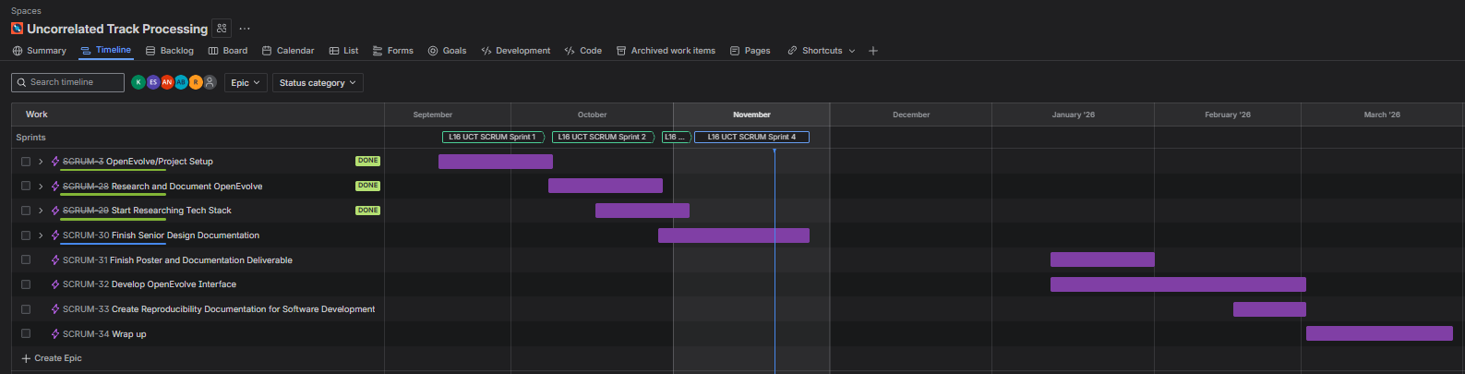
Figure 2.51: This figure showcases timeline and completed sprints towards the end of Senior Design I. Alongside future sprints for the next semester when Senior Design II starts. Current development has already gone underway, so the group is ahead in regard to the sprint timeline.

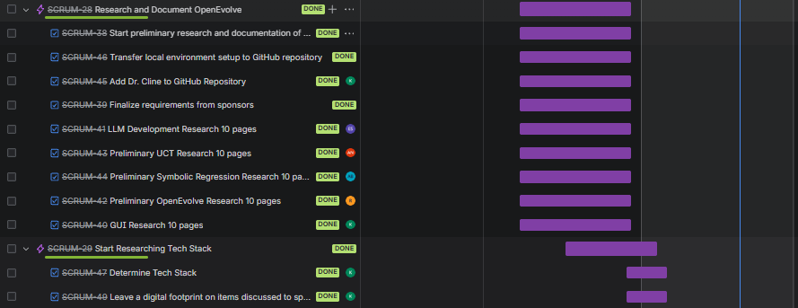
Figure 2.52: This figure showcases an in-depth look into the tasks filled inside each sprint.
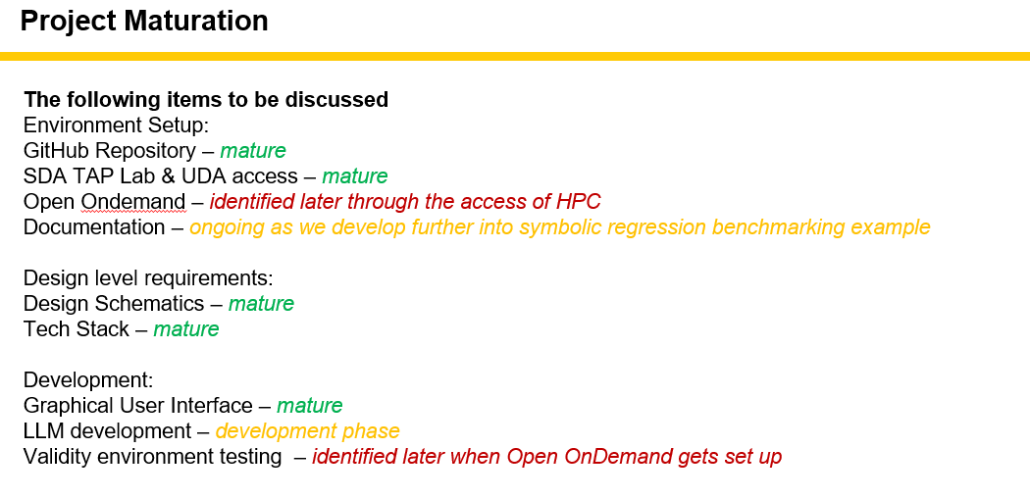
Figure 2.53: This figure showcases the most recent milestones showcased each week in a sponsor meeting with the team. (Green: mature, yellow: in progress, red: blockers) Current milestones reached for the team are Analytic Console (GUI) designs are finished, LLM development is already developed but has bugs that need to be fixed, and Open OnDemand is a web feature that allows us to SSH into the HPC but has not been fully set up yet so validity testing for GUI and LLM development have not been set up yet.

Chapter 3. Uncorrelated Track Processor

3.1 Introduction
In a brief introduction UCT processing underpins timely and accurate orbit estimation. Which is a critical step in detecting, correlating, and responding to potential threats in Space Domain Awareness. Adversaries exploit CCDM to degrade sensor data quality, leaving traditional algorithms unable to reconcile sparse and/or noisy observations into reliable orbital estimates.

But in a simpler and more in-depth explanation, uncorrelated Track Processor (UCTP) is a part of a Space Domain Awareness (SDA) system that tries to make sense of uncorrelated sensor observations that do not match any known tracks from known databases. In practice, sensors (radar, optical, etc.) produce tracks of objects moving through space. Most tracks can be correlated to existing orbits in the catalog. But when a track cannot be matched it becomes uncorrelated. A UCT processor:
- Takes these uncorrelated tracks and rapidly estimates a plausible orbit from incomplete or noisy data. (i.e., downsampling or simulating)
- Decides whether the track likely represents a new object, a maneuvering object, a mis-association/cross-tag, or just bad data.
- Produces candidate orbits and scores/metrics that downstream systems can use for threat detection, catalog updates, and tasking sensors.

Since the data is often sparse, noisy, or deceptive (i.e., CCDM: Camouflage, Concealment, Deception, and Maneuver), UCT processing is considered a very difficult problem to solve. Since it isn’t just a single algorithm to solve everything but rather a diverse number of approaches to solving such a problem.

3.1.1 UCTP Workflow and Code
Currently we are working with the SDA TAP Lab’s UCTP benchmarking code, which has already been developed by previous groups and professionals over the years. The framework can be broken down into two pipelines, dataset generation and evaluation.

3.2 Dataset Generation
The basic dataset generation workflow allows the user to choose the desired dataset characteristics, such as object type, orbital regime, and data quality. Which is then downsampled or simulated observations again matching data. This converts them to trackTLEs, which then the result is stored into a database that is fed into UCTP.

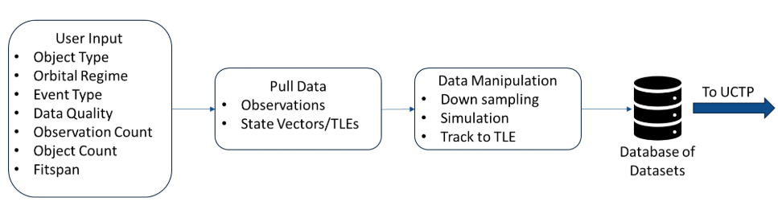
Figure 3.21: This figure showcases the dataset generation workflow as explained previously in 3.2.

3.2.1. Data Shaping
When creating the database from the results, there are many ways to shape the data:
- Window Selection: Allows us to select a slice of time or which part of the orbit or viewing geometry to keep. This allows us to create a tier system that allows us to score the current time window of the data. The first step in building a dataset is choosing a good time window. A Tier-1 window is ideal: all user criteria are met using real data only, with no downsampling or simulation. A Tier-2 window meets the criteria but requires downsampling (removing some observations), with no simulation. A Tier-3 window needs simulated observations for existing objects in the dataset to reach the desired orbital coverage and/or number of observations. A Tier-4 window needs simulated observations for new reference objects to reach the desired number of target objects. In Tier-3 and Tier-4, downsampling may or may not be used, but it does not change the tier. Tier-5 means the selected criteria cannot be satisfied at all.
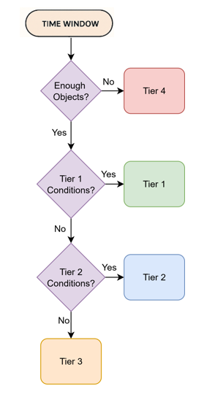
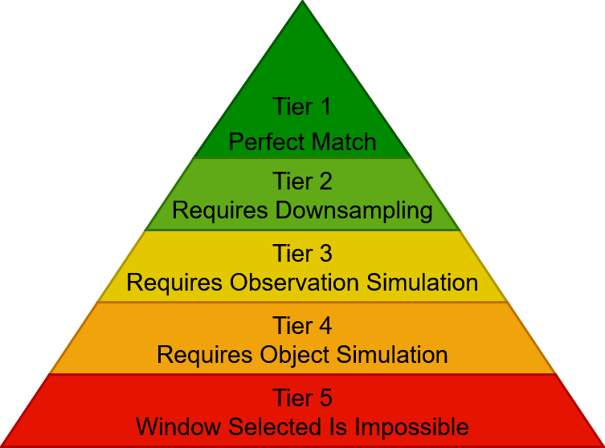
Figure 3.2.11: This figure showcases the tier system on how we score the data into the dataset.

- Downsampling: Which allows us to simulate poor data quality from good measurements by removing observations. This is done through three metrics: Orbital Coverage, Maximum Track Gap, and Total Observation Count.
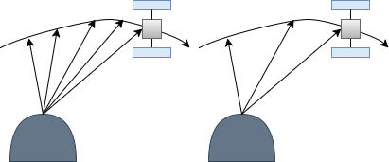
Figure 3.2.12: This figure showcases how we are downsampling data by removing observations.

- Simulation: This applies Gaussian noise to both the propagated positions and inverted right ascension and declination values. This determines simulated azimuth and elevation values from the simulated angular values and known site locations of latitude, longitude, and altitude.
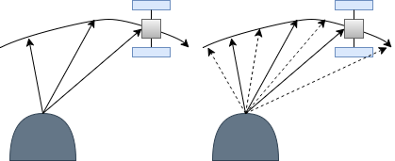
Figure 3.2.13: This figure showcases how we are simulating data by taking the state vector of the reference orbit and propagate to the observation epoch.

Datasets are generated according to desired characteristics input by the end user through a 16-character string:
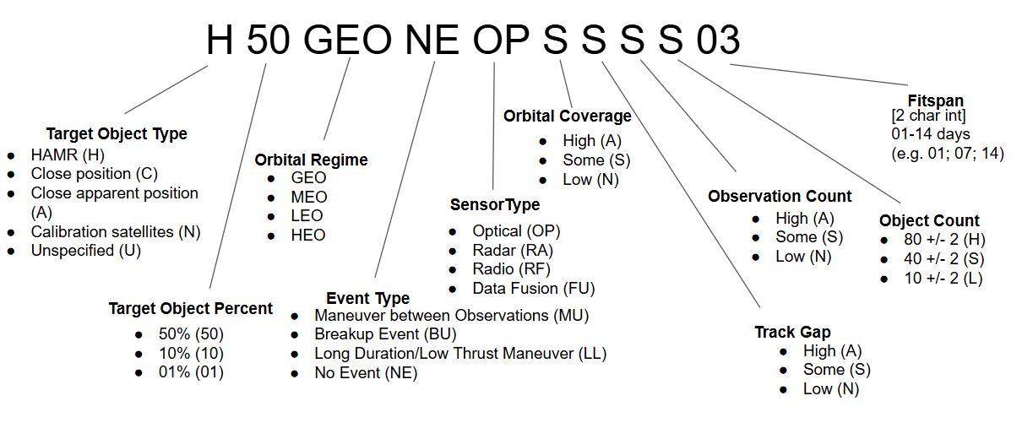
Figure 3.2.12: This figure showcases the dataset code which is a unique 16-character string encoding from the user selected data parameters.

3.3 Evaluation Workflow
The evaluation pipeline is how the data is set up in the output file through the evaluation metrics of orbit association, state metric, residual metric, and binary metric. This is then comprised into one file consisting of all these metrics alongside the current satellite id and all of its observations.

3.3.1 Orbit Association Metric
The orbit association metric is the preprocessed data to allow the other metrics to be created. This is only edited once more sensor types are integrated. The evaluation framework will associate Candidate Orbits with Reference Orbits by solving an optimal assignment problem using a modified Jonker-Volgenant algorithm with no initialization. The assignment will also be using a linear sum assignment function from the Python library scipy.optimize.

The assignment cost matrix is constructed following:
- For every permutation of Reference Orbit/Candidate Orbit pair, the Reference Orbit is propagated to the Common Epoch using Orekit (see Propagation).
- If the Reference Orbits and Candidate Orbits are given in TLEs, they are both converted to 6D state vectors (see TLE to State Vector)
- The 6D vector difference between the Propagated Reference and the Candidate Orbit is taken.
- The L2 norm of that difference vector is assigned as the cost.

Then propagation occurs through state vector propagation, covariance propagation, and TLE propagation. This step is to confirm/validate/verify.

3.3.2 State Metrics
The state metrics refers to comparing the Candidate orbit to the Reference orbit either as state vectors or TLEs to determine how accurate the orbit estimation is.

For state metrics for state vectors, the following metrics are computed for each pair of the Reference orbit/Candidate orbit:
- L2 error: Length of the difference vector between the reference and candidate states, computed for position only, velocity only, and the full 6-D state.
- Bias: Average offset of the candidate from the reference in each position and velocity component.
- Mahalanobis Distance (MD): Measures of how far the candidate state is from the reference state, taking both covariances into account:
$$MD=(x_{\text{ref}}-x_{\text{cand}})^{T}Σ^{-1}(x_{\text{ref}}-x_{\text{cand}})$$

where $Σ=Σ_{\text{ref}}+Σ_{\text{cand}}$.

- MD p-score: Computed from a chi-squared distribution with 6 degrees of freedom as
$$1-P(χ_{6}^{2}≤MD).$$

This is the probability (0.0–1.0) that the reference and candidate are the same orbit, given their covariances. Higher values mean higher confidence.

- NEES (Normalized Estimation Error Squared): Similar to MD but uses only the candidate covariance:

$$NEES=(x_{\text{ref}}-x_{\text{cand}})^{T}Σ_{\text{cand}}^{-1}(x_{\text{ref}}-x_{\text{cand}}).$$
- NEES p-score: Also, from a chi-squared distribution with 6 degrees of freedom:
$$1-P(χ_{6}^{2}≤NEES).$$
This measures how well-calibrated UCTP’s covariance is.
    - p-score < 0.5 → processor is overconfident (covariance too small).
    - p-score > 0.5 → processor is underconfident (covariance too large).

For state metrics for TLEs, for a given pair of TLE/Candidate. TLE is propagated to the common epoch. Both TLEs are converted to state vectors to generate L2 Norm and bias metrics from state metrics for state vectors. The other metrics are not computed due to TLEs lacking covariance and uncertainty.
3.3.3 Residual Metrics
Residual metrics measure how far the predicted observations are from the actual ones, on the unit sphere (i.e., angular error on the sky). We propagate the Candidate Orbit to each observation time and compare:
- Reference vs. Candidate: Compare observations (or trackTLEs) from the Reference Orbit to those predicted by the Candidate Orbit → measures accuracy relative to truth.
- Candidate vs. Candidate: Compare Candidate Orbit’s own observations (or trackTLEs) to its predicted ones → measures precision and internal consistency.

For each case, we compute the root mean squared (RMS) error between the actual and predicted observations or trackTLEs.

3.3.4 Binary Classification Metrics
The binary classifier labels each observation or trackTLE in the benchmark dataset as one of four types:
- True Positive (TP): The observation belongs to both the Candidate Orbit and the Reference Orbit it is associated with.
- True Negative (TN): The observation does not belong to any Candidate Orbit or Reference Orbit.
- False Positive (FP): The observation is assigned to a Candidate Orbit, but it does not actually belong to the associated Reference Orbit.
- False Negative (FN): The observation is not assigned to a Candidate Orbit, but it does belong to the associated Reference Orbit.

From these counts, we compute standard binary classification metrics:
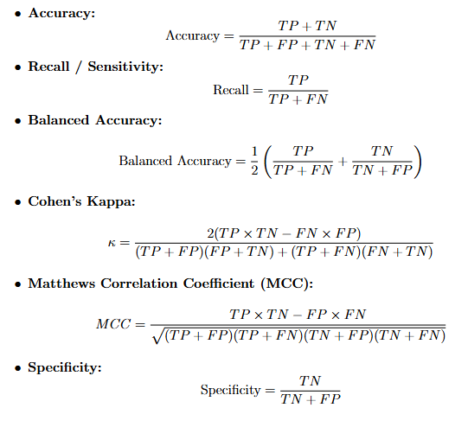

These metrics together describe how well the UCTP identifies correct associations and avoids incorrect ones.
​ ​

3.3.5 Processor and Outputs
All of these metrics that are explained earlier are the preprocessor portion of the framework. They allow us to create output JSON data files that we then feed into the UCTP to get out evaluation and benchmark.

3.3.6 Conclusion
So, what is the importance of these metrics and evaluation outputs? UCTP is trying to figure out the objects in a dataset. There are two main things that would be nice to optimize, which are the accuracy of the fitness. An example is state metrics: comparison between reference state vector where the object really is versus the Candidate state vector. Residual metrics where it references the root means squared error, which is the difference between true observation versus reference observation. This calculation is done through square root of the average of the sum of the residuals. Binary calculation metrics which are important to return and understand how these qualities affect the overall fitness. Or a 6x6 covariance uncertainty, where we calculate a distance which is scaled by the sum of the covariance matrices, normalized estimation error, and standard distance in 6-dimensional space. Or lastly, the speed of the convergence to a solution.

These are the many problems we aim to solve that UCTP has trouble with. So now we understand what UCTP is and what its limitations are. How do we go about solving it? As stated, before in this document the problem with UCTP is that pipelines have been around for quite a while now. But the problem is that UCT processing does not have a well-known solution to compare it to. This makes it hard to improve upon the algorithms for future use and also what Space Domain Awareness (SDA) aims to do with real-time monitoring for UCTP. We need benchmark datasets with known solutions and performance metrics to evaluate UCTP performance.

3.4 Definitions of Datasets
These given data sets will be given according to the desired characteristics input by the end user. The characteristics of the dataset will be encoded in a 16-character string shown below:
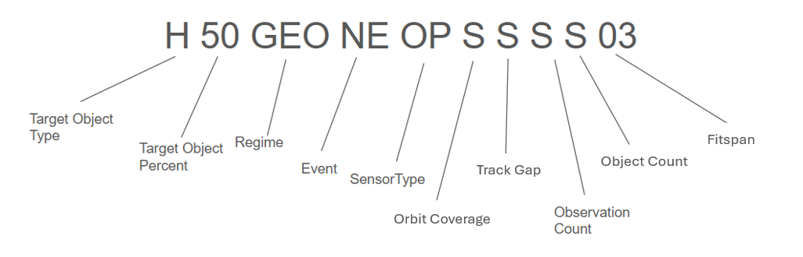
Figure 3.41: This figure showcases the 16-character string that is generated for the dataset being fed into the processor.

Target Object Types:
The target object types are a simple overall classification of the type of object to be given and/or later simulated. The relationship between the letter of classification and characteristics of this classification is defined by the graph:

High Area to Mass Ratio (HAMR) | Close Objects | Close Apparent Objects | Unspecified | Calibration
> 1 m^2/kg | distance<X km  velocity<X m/s | Angles within:  X ° | Datasets unconstrained by object types | Well-tracked objects only
H | C | A | U | N

Target Object Percent:
The target object percentage is the percentage of the target object to be included in the given dataset. Any value from 100 to 01 or UN (unspecified) is valid. When UN is chosen it leaves the makeup of the data set to the choice of the algorithm, populating the data set with a natural distribution of objects. The reason it is directly correlated with the object type is because objects of type Unspecified must have UN as their target object percent.

Orbital Regime:
The orbital regime is the measurement of the semi-major axis a in kilometers. There are 4 regimes Low Earth Orbit (LEO), Middle Earth Orbit (MEO), Geosynchronous Orbit (GEO) and Highly Elliptical Orbit (HEO) and the orbital regime of the object can take up any number of combinations of these 4 regimes. These combinations are LMO, LGO, LHO, MGO, MHO, GHO, LMG, LGH, MGH, and ALL. Combinations of 2 are the first letters of the unique word from the 4 regimes (L, M, G, H) followed by an O to stand for “orbit” and combinations of 3 are the first letters paired together. All letters are sorted by the order of their regime, L being first, H being last and so on. The range of a by its regime are defined by the chart:
Manuever Between OBS | Breakup | Long Duration/low thrust | No Events
MB | BU | LL | NE

Sensor Type
The type of sensor that would pick up the object in orbit (when searched or generated).
Optical | Radar | Radio Frequency (RF) | Fusion of all sensor types | Optical/RF | Optical/Radar | Radar/RF
OP | RA | RF | FU | OR | RO | RR

Orbit Coverage:
The orbital coverage is the amount of the object's path covered by the data, based on its orbital regime there are accepted minimum values for identification based on how covered the object in orbit is.
The relationship between the orbital regime and the minimum (not Low coverage) acceptable orbital coverage to identify the object in orbit is shown by the chart.
LEO (Low <0.0213% covered)
MEO (Low <0.0449% covered)
GEO (Low <41.656% covered)

The letters that represent orbital coverage are A, S, N, and the values are defined by the chart below:
>90% of objects have low orbital coverage | 40-60% of objects have low orbital coverage | <10% of objects have low orbital coverage
A | S | N

Track Gap:
The track gap is the longest duration of time between observations of an object, the shorter the better. According to our sponsors, a ‘long’ track gap is defined as a duration of two orbital periods of the object. When preparing the example data, Orbital Regime and Fitspan take precedence over track gap which means the track gap; when given, is more likely to be considered ‘long’. This infers that track gap as a metric for identifying objects is less important, which is possibly why the generated data is less ‘reliable’ than the data directly from the UDL. The convention also uses the same letters that Orbital Coverage uses but it is important to note that the value of representation is different than Orbital Coverage:
>90% of objects have a long track gap | 40-60% of objects have a long track gap | <10% of objects have a long track gap
A | S | N

Observation Count:
The observation count is the total number of unique observations per object per 3-day-timespan. A ‘low’ observation count is less than 50, standard’ observation count is between 50-150 and objects with greater than 150 observations will not be used or will be down sampled to a ‘standard’ observation count. This uses the same letters that Orbital Coverage uses but it is important to note that the value of representation is different than Orbital Coverage:
>90% of objects have low observation count | 40-60% of objects have low observation count | <10% of objects have low observation count
A | S | N

Object Count:
The object count is the total number of objects to be included in the object data set give or take 2 objects, it is identified by three letters H, S, L. The values of the letters are defined by the chart below:

High number of objects:  80 +/- 2 | Standard Number of Objects:  40 +/- 2 | Low number of objects:  10 +/- 2
H | S | L
The fitspan is the duration of the dataset spans in days from 01 to 14.

Actively Assembling the Dataset. Fit metrics determines the unit-sphere projected great circle residuals between the actual observations and the propagation observations. The function is split into two categories:
- Comparison of the reference (truth) observations with the associated orbits (how accurate a correlated state is)
- Comparison of the reference (truth) observations with the UCTP output (how precise a correlated state is)
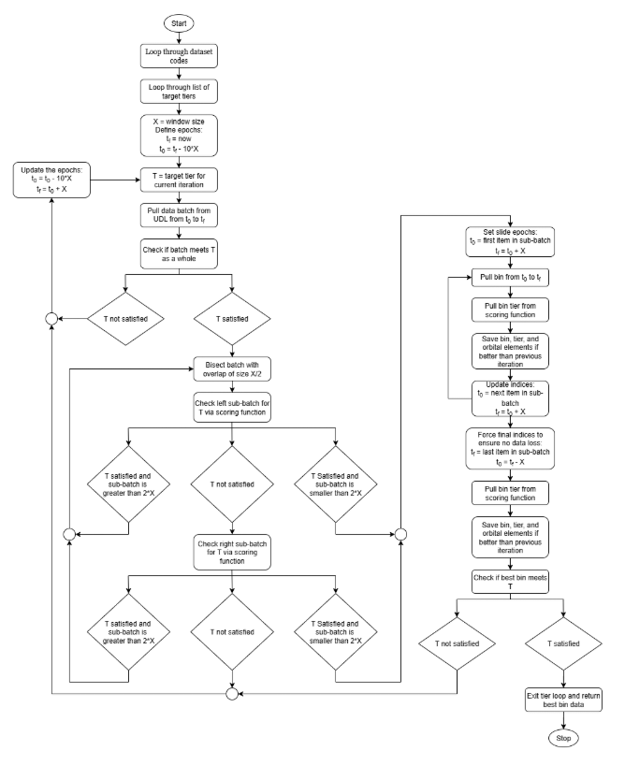
The character string makes up the queries that. The steps to then use these parameters for the given datasets are as follows: (on the following page
The first step in creating a dataset is to identify the window as stated previously. The most optimal time is when there is no simulation or down sampling required. Which is shown on the following chart.
Figure 3.42: This diagram showcases the workflow for evaluation and data generation for UCTP.

Time Window Selection
The first step to fully preparing and giving the data is identifying an ideal time window based off of the fitspan and other variables present in the string. The resulting quality of time window selection is separated into tiers according to this chart:
Tier 1 | Tier 2 | Tier 3 | Tier 4 | Tier 5
(optimal)  No downsampling  No simulation | No simulation | Simulation of objects already present | Simulation of new objects | (worst)  Criteria is impossible

3.5 Unified Data Library (UDL)
The Unified data library has literally hundreds of API endpoints for information collected across different disciplines. These range from aircraft to objects in space. Our sponsor specifies that the schemas of the information will be of the form EOObservation_Full or Elset_Full, the parameters of the schema for the EOObservation_Full is as follows:

EOObservation_Full: Model representation of observation data for electro-optical based sensor phenomenologies.

Id string: Unique identifier of the record, auto generated by the system.

classificationMarking string: Classification marking of the data in IC/CAPCO Portion-marked format. (IC/CAPCO Portion-marked is the standardized way the U.S. Intelligence community applies classification markings to individual portions of a document)

obTime string (date-time): Object detection time in ISO 8601 UTC, up to microsecond precision. (For example, 3pm EST = 2025-11-20T20:00:00Z)

corrQuality number (double): Object Correlation Quality score of the observation when compared to a known orbit state, the value ranges differ from provider to provider (non-standardized).

idOnOrbit string: Unique identifier of the target on-orbit object, if correlated.

idSensor string: Unique identifier of the reporting sensor.

idSkyImagery string: Unique identifier of the Sky Imagery.

collectMethod enum (string): Method indicating telescope movement during collection, while this is a standardized enumerator how each provider utilizes these options and the exact description of these values varies from provider to provider. The enumerators are as follows: AUTOTRACK, MANUAL AUTOTRACK, RATETRACK, MANUAL RATE TRACK, SIDEREAL, MANUAL SIDEREAL

satNo integer (32 bit): Satellite/Catalog number of the target on-orbit object.

taskId string: Optional identifier to indicate the specific tasking which produced this observation.

transactionId string: Optional identifier to track a commercial or marketplace transaction executed to produce this data. Like all ids, this is for traceability and uniqueness for the observation event, however in this case it is to distinguish where this information is from on the commercial side of data.

trackId string: Optional identifier of the track to which this observation belongs. (Track is the record of an object's position at a specific timestamp.)

obPosition enum (string): An optional value of the position of this observation within a track, the values are as follows:
obPosition | Description
FENCE | The observation was taken at the start of a collection window or boundary condition.
FIRST | This is the first detection of the object in a sequence of observations.
IN | Intermediate observation within a sequence.  (not first or last observation)
LAST | Final observation in a sequence before the object leaves the sensor’s fields of view or the collection ends.
SINGLE | There is only one observation of the object, not a sequence
null | No assumption should be made regarding whether other observations may or may not exist to compose a track.

origObjectId string: Optional identifier provided by observation source to indicate the target onorbit object of this observation. This may be an internal identifier and not a valid satellite number.

origSensorId string: Optional identifier provided by observation source to indicate the sensor identifier which produced this observation. This may be an internal identifier and not a valid sensor ID.

uct Boolean: Boolean value that indicates whether this observation is part of an uncorrelated track or was unable to be correlated to a known object. This flag should only be set to true by data providers after an attempt to correlate to an on-orbit object was made and failed. If unable to correlate, the ‘origObjectId’ field may be populated with an internal data provider specific identifier.
azimuth number (double): Line of sight azimuth angle in degrees and topocentric frame. Reported value should include all applicable corrections as specified on the source provider. The definition of this value and a visual representation are as follows:
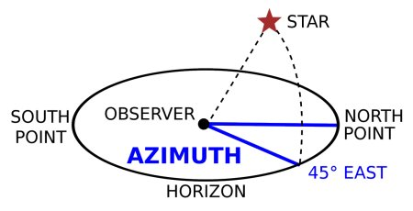
Figure 3.51: This figure showcases the azimuth which is the direction of a celestial object from the observer, expressed as the angular distance from the north or south point of the horizon to the point at which a vertical circle passing through the object intersects the horizon.
azimuthMeasured Boolean: Optional flag indicating whether the azimuth value is measured [true] or computed [false]. If null, the provider must be contacted for the proper value. If measured, the limit of the accuracy of the azimuth is relative to the sensor, if computed the limit of the accuracy is relative to the program that computes it.

azimuthBias number (double): Sensor line of sight azimuth angle bias in degrees.

azimuthRate number (double): Rate of change of the line-of-sight azimuth in degrees per second.

elevation number (double): Line of sight elevation in degrees and topocentric frame. Reported value should include all applicable corrections from the source provider.

elevationMeasured Boolean: Optional flag indicating whether the elevation value is measured [true] or computed [false]. If null, the provider must be contacted for the proper value. If measured, the limit of the accuracy of the elevation is relative to the sensor, if computed the limit of the accuracy is relative to the program that computes it.

elevationUnc number (double): One sigma uncertainty in the line-of-sight elevation angle, in degrees.

elevationBias number (double): Sensor line of sight elevation bias in degrees.

elevationRate number (double): Rate of change of the line of sight elevation in degrees per second.

range number (double): Line of sight range in kilometers (km). If referenceFrame (another value defined later) is null, Julian Date 2000 (J2K) should be assumed. All corrections should be provided by the data provider.

rangeMeasured Boolean: Optional flag indicating whether the range value is measured [true] or computed [false]. If null, the provider must be contacted for the proper value. If measured, the limit of the accuracy of the range is relative to the sensor, if computed the limit of the accuracy is relative to the program that computes it.

rangeUnc number (double): One sigma uncertainty in the line-of-sight range, in kilometers.

rangeBias number (double): Sensor line of sight range bias in km.

rangeRate number (double): Range rate in km/s. If referenceFrame is null, J2K should be assumed. All corrections should be provided by the data provider.

rangeRateMeasured Boolean: Optional flag indicating whether the rangeRate value is measured [true] or computed [false]. If null, the provider must be contacted for the proper value (measured or computed). If measured, the limit of the accuracy of the rangeRate is relative to the sensor, if computed the limit of the accuracy is relative to the program that computes it.

rangeRateUnc number (double): One sigma uncertainty in the line-of-sight range rate, in km/s. ra (right ascension) number (double): Line of sight right ascension, in degrees, in the specified referenceFrame. If referenceFrame is null, J2K should be assumed. All applicable corrections should be specified by the provider. Here is a diagram of right ascension:

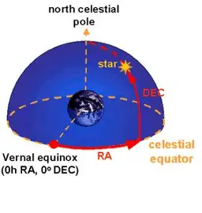

Figure 3.52: This figure showcases the right ascension.
raMeasured Boolean: Optional flag indicating whether the ra value is measured [true] or computed [false]. If null, the provider must be contacted for the proper value (measured or computed). If measured, the limit of the accuracy of the ra is relative to the sensor, if computed the limit of the accuracy is relative to the program that computes it.

raRate number (double): Line of sight right ascension rate of change, in degrees/sec, in the specified referenceFrame. If referenceFrame is null, then J2K should be assumed.

raUnc number (double): One sigma uncertainty in the line-of-sight right ascension angle, in degrees.

raBias number (double): Sensor line of sight right ascension bias in degrees.

declination number (double): Line of sight declination, in degrees in the specified referenceFrame. If referenceFrame is null, then J2K should be assumed. Here is a diagram of declination:
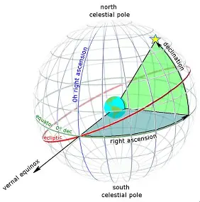
Figure 3.53: This figure showcases the idea of declination.

declinationMeasured Boolean: Optional flag indicating whether the declination value is measured [true] or computed [false]. If null, the provider must be contacted for the proper value (measured or computed). If measured, the limit of the accuracy of the declination is relative to the sensor, if computed the limit of the accuracy is relative to the program that computes it.

declinationRate number (double): Line of sight declination rate of change, in degrees/sec, in the specified referenceFrame. If referenceFrame is null then J2K should be assumed. declinationUnc number (double) One sigma uncertainty in the line-of-sight declination angle, in degrees.

declinationBias number (double): Sensor line of sight declination angle bias in degrees.

los (Line of sight) number (double): Line of sight cartesian position of the target, in km, in the specified referenceFrame. If referenceFrame is null, then J2K should be assumed. This line of sight is divided into losx, losy, losz, which are relative to the respective cartesian axis.

losUnc number (double): One sigma uncertainty in the line of sight pointing in micro-radians.

losvel number (double): Line of sight cartesian velocity of the target, in km, in the specified referenceFrame. If referenceFrame is null then J2K should be assumed. This line of sight is divided into losxvel, losyvel, loszvel, which are the velocities relative to the respective cartesian axis.

senlat number (double): Sensor World Geodetic System 1984 (WGS84) latitude at obTime (if mobile/onorbit) in degrees. If null, can be obtained from sensor info. senlat ranges from -90 to 90 degrees (negative values south of equator)

senlon number (double): Sensor WGS84 longitude at obTime (if mobile/onorbit) in degrees. If null, can be obtained from sensor info. senlon ranges from -180 to 180 degrees (negative values west of Prime Meridian)

senalt number (double): Sensor WGS84 altitude at obTime (if mobile/onorbit) in km.

sen number (double): Cartesian position of the observing mobile/onorbit sensor at obTime, in km, in the specified senReferenceFrame (defined later). If senReferenceFrame is null, then J2K should be assumed. This value is split into senx, seny, senz which are relative to the respective cartesian axis.

senvel number (double): Cartesian velocity of the observing mobile/onorbit at obTime, in km/sec, in the specified senReferenceFrame. If senReferenceFrame is null then J2K should be assumed. This value is split into senvelx, senvely, senvelz which are relative to the respective cartesian axis.

senQuat Array[number (double)]: The quaternion describing the rotation of the sensor in relation to the body-fixed frame used for this system into the local geodetic frame at observation time (obTime)/ The array element order convention is scalar component, followed by the three vector components (qc,q1,q2,q3).

fovCount integer (32 bit): The number of Resident Space Objects (RSOs) detected in the sensor field of view.

fovCountUCT integer (32 bit): The number of uncorrelated tracks in the field of view.

expDuration number (double): Image exposure duration in seconds. For observations performed using frame stacking or synthetic tracking methods, the exposure duration should be the total integration time.

zeroptd number (double): Result of this formula: 2.5 * log₁₀(zero_mag_counts (constant) /expDuration)

netObjSig number (double): Result of this formula = counts (constant) / expDuration

netObjSigUnc number (double): Net object signature uncertainty = counts (constant)/ expDuration

mag number (double): Measure of observed brightness calibrated against the Gaia G-band in units of magnitudes.

magUnc number (double): Uncertainty of the observed brightness in units of magnitudes.

magNormRange number (double): Formula: mag - 5.0 * log ₁₀ (georange (defined later) / 10⁶)

geolat number (double): For GEO detections, the longitude in degrees north.

geolon number (double): For GEO detections, the longitude in degrees east.

geoalt number (double): For GEO detections, the altitude in km.

georange number (double): For GEO detections, the range in km.

skyBkgrnd number (double): Average Sky Background signal in Magnitudes. Sky Background refers to the incoming light from an apparently empty part of the night sky.

primaryExtinction number (double): Primary Extinction Coefficient, in Magnitudes. The Primary Extinction is the coefficient applied to the airmass to determine how much of the observed visual magnitude has been attenuated by the atmosphere. Extinction, in general, describes the absorption and scattering of electromagnetic radiation by dust and gas between an emitting astronomical object and the observer.

primaryExtinctionUnc number (double): Primary Extinction Coefficient Uncertainty, in Magnitudes.

solarPhaseAngle number (double): The angle, in degrees, between the target-to-observer vector and the target-to-sun vector

solarDecAngle number (double): Angle from the sun to the equatorial plane.

shutterDelay number (double): Shutter delay in seconds.

timingBias number (double): Sensor timing bias in seconds.

rawFileURI string: Optional URI location for a separate API endpoint to retrieve the raw data file that produced this record.

intensity number (double): Intensity of the target for infrared (IR) observations, in kw/sr/um.

bgIntensity number (double): Background intensity for IR observations, in kw/sr/um.

descriptor string: Optional source-provided and searchable metadata of the data.

source string: Source of the data.

origin string: Originating system or organization which produced the data, if different from the source. The origin may be different than the source if the source was a mediating system which forwarded the data on behalf of the origin system. If null, the source may be assumed to be the origin.

dataMode enum (string): This is the “mode” of the data, or how accurate to real life the data is itself.

dataMode | Description
EXERCISE | Data pertaining to a government or military exercise. May include both real and simulated data.
REAL | Data collected or produced that pertains to real-world objects, events and analysis.
SIMULATED | Synthetic data generated by a model to mimic real-world datasets.
TEST | Specific datasets used to evaluate compliance with specifications and requirements, and for validating technical, functional and performance characteristics.

tags Array[string]: Optional array of provider/source specific tags for this data, tags are used for implementing data owner conditional access controls to restrict access to the data.

createdAt string(date-time): Time the row was created in the database, auto-populated by the system.
createdBy string: Application user who created the row in the database, auto populated by the system.

zeroPtdUnc number (double): This is the uncertainty in the zero point for the filter used for this observation/row in units of magnitude. This value is used for differential photometry.

eoobservationDetails EOObservationDetails_Full: The EOObservationDetails_Full is another data schema entirely, whose schema is written out in the UDL. It is a model representation of additional detailed observation data for electro-optical based sensor phenomenologies.

onOrbit Onorbit_Full: The Onorbit_Full is another data schema entirely, like the EOObservationDetails_Full. It is a model representing on-orbit objects or satellites in the system.

referenceFrame enum (string): The reference frame of the EOObservation measurements. If null, assume J2K. Here are the values for referenceFrame: [J2K, GCRF ,ITRF ,TEME]

senReferenceFrame enum (string): The reference frame of the observing sensor state. If null, assume J2K. Here are the values for senReferenceFrame: [J2K, EFG/TDR, ECR/ECEF, TEME, ITRF, GCRF]

umbra Boolean: Boolean indicating that the target object was in umbral eclipse at the time of this observation.

penumbra Boolean: Boolean indicating that the target object was in a penumbral eclipse at the time of this observation.

origNetwork string: The originating source network this record was created, auto-populated by the system.

sourceDL string: The source data library from which this record was received . This can be a remote or tactical UDL or another data library. If null, the record should be assumed to have originated from the primary Enterprise UDL.
type string
Read only field specifying the type of observation.

Richness in Data: The richness of the data provided by every UDL API endpoint cannot be understated, each measurement coupled with an uncertainty value, multiple enumerators changing the exact context of the observation itself. Some values are just results of simple calculations using the given data values. With this richness in data came a large problem the team had, which was trying to understand what this data truly means in relation to the UCT Processing pipeline. For example, the eoobservationDetails and onOrbit values inside the EOObservation_Full schema are schemas themselves which have a multitude of parameters all with similar precision and paper trails for the information itself. An AI just to look through the schemas and give a crash course to people getting into the UDL or any system like it would be a project in itself.

Effectively Using the Data: The data itself is rich, very rich; however, our sponsor provided a narrower list of the elements from each observation with the formatting that they wanted the Open Evolve evolved program to output as. This means that of the 90 elements of the schema given originally, the output contains much less elements compared, the exact value varies depending on whether the data is Elset data or an EOObservation_Full data.

Elset_Full: The Elset data contains information pertaining to orbital characteristics of on-orbit objects. However, going into detail about its parameters isn't as important as only some of the expected values are included inside the format provided by the sponsor, these values are epoch, cov covReferenceFrame, linarSolar, solarRadPress, solidEarthTides,inTrackThrust,rms and algorithm.

3.6 Conclusion
UCTP draws on a wide range of data sources. Many of its orbit estimation and accuracy metrics are built from publicly available services that track known objects in orbit. When you look at how this data is generated, transformed, and fed into the processor for evaluation, it becomes clear just how complex and multidisciplinary UCTP really is. That naturally leads to the key question: how do we tame such a complex multi-disciplinary system with many moving parts into an AI architecture?

Chapter 4. OpenEvolve

4.1 Introduction
OpenEvolve is an open-source framework designed to automate algorithm discovery and code optimization. Instead of the usage of UCTP algorithms and tuning them manually, OpenEvolve uses large language models (LLMs) together with evolutionary search using island-based convergences to automatically generate, modify, and evaluate candidate programs based off of evaluation metrics. At each iteration, the system proposes small, structured “mutations” to the code, scores them using user-defined metrics, and then keeps the best performers for the next generation. This allows the program to keep diversification to combat again premature convergences. Over time, this process explores a wide range of algorithmic designs and converges toward higher-quality solutions.
For UCTP, OpenEvolve directly addresses the lack of standardized benchmarks and systematic evaluation. By pairing our benchmark datasets and metrics (state, residual, binary classification) with OpenEvolve’s automated search, we can rapidly test many different UCTP algorithms, compare them in a consistent, quantitative way, and discover novel approaches that might not emerge from manual design alone. In this way, OpenEvolve becomes both a benchmarking engine and a code-generation tool, helping us identify, refine, and justify UCTP algorithms for Space Domain Awareness.

4.2 OpenEvolve Basic Functionality & Process
Due to the complexity of OpenEvolve’s architecture and process, this section serves to showcase a simple problem that goes through the process for the reader to understand. Which will then be connected to the UCTP framework and how we plan to integrate UCTP into OpenEvolve’s AI architecture. We first start off with a simple program in computer science. That program being Maximum Subarray Sum taken from LeetCode:
Example 1:
Input: nums = [-2,1,-3,4,-1,2,1,-5,4]
Output: 6
Explanation: The subarray [4,-1,2,1] has the largest sum 6.
Example 2:
Input: nums = [1]
Output: 1
Explanation: The subarray [1] has the largest sum 1.
Example 3:
Input: nums = [5,4,-1,7,8]
Output: 23
Explanation: The subarray [5,4,-1,7,8] has the largest sum 23.

Using a brute force method, we can get the answer with a runtime of O(n³). Which is not the best when it comes to the most optimal solution. Using data structure techniques, we know we can get an optimal solution of O(n) using a left pointer by skipping negative evaluations and a right pointer to iterate through. How OpenEvolve works here is using this example of trying to get the most optimal solution to this maximum subarray sum problem. OpenEvolve will need three inputs:
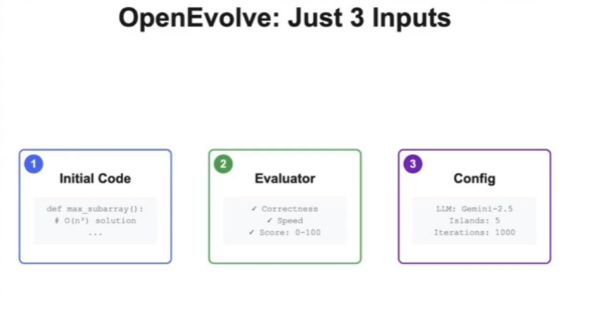
Figure 4.21: This figure showcases the required inputs to run OpenEvolve. Where we input the O(n³) code of maximum subarray sum problem. And with the evaluator file, we ask OpenEvolve to find a more optimal solution through speed and correctness. With these metrics we can score each program through each iteration. The Config is what we use to code generate and manipulate. In OpenEvolve’s benchmark research, they find that using simple LLMs like Gemini-2.5 performs the best.

Now that we have the required files needed to run OpenEvolve, how does it find the best program? OpenEvolve uses a technique called island-based convergence which comes from island-model evolutionary algorithms. Where instead of evolving one big population of programs, we can evolve smaller populations (“islands”) to promote parallelism. The following figure will give a better example of how OpenEvolve finds the best program:
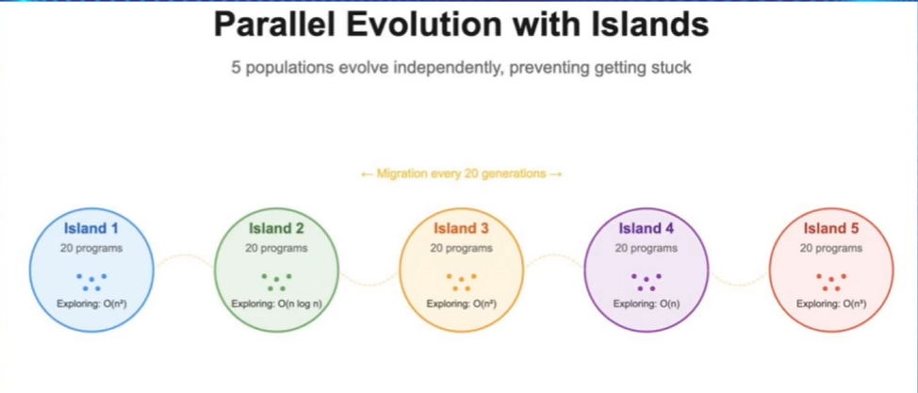
Figure 4.22: This figure showcases the different runtimes OpenEvolve tries to test when finding the optimal solution to the maximum subarray sum problem. Where every generation, we do migrations where we take the best performing programs from one island and move them to another. This allows us to have fast convergence times and also allows us to maintain diversity to allow the best solutions to spread throughout the migration process. This prevents

Where every n generation, we do migrations where we take the best performing programs from one island and move them to another. This allows us to have fast convergence times and also allows us to maintain diversity to allow the best solutions to spread throughout the migration process. This prevents the islands from becoming similar too quickly and also prevents premature convergences. This technique helps promote exploration and parallelism by isolating populations instead of having to converge on one big population or code. Each island has its own evolutionary loops, which is what we know from the current outputs of OpenEvolve’s directory.

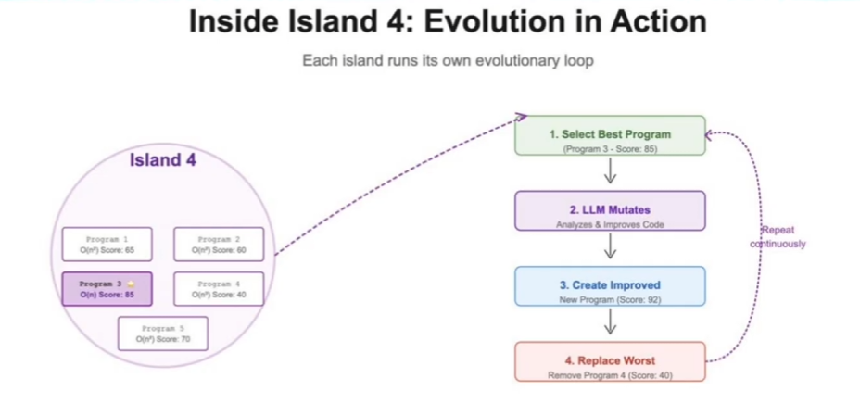
Figure 4.23: This figure showcases OpenEvolve uses the evaluation metrics to score each program in order to find which program to migrate when trying to find the best solution.

To showcase how dynamic OpenEvolve is when it comes to evolving code, in this case when solving the maximum subarray sum problem. It knows that based off the user metrics of scoring how well a program does base off of speed and accuracy. It knows that the most optimal solution we can get is O(n). In this case it did find a solution which is using prefix sum approach. But the scoring of the solution is still 85/100. Is there a better way to solve this problem?
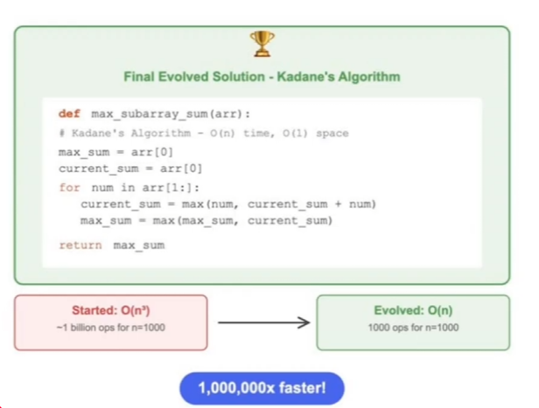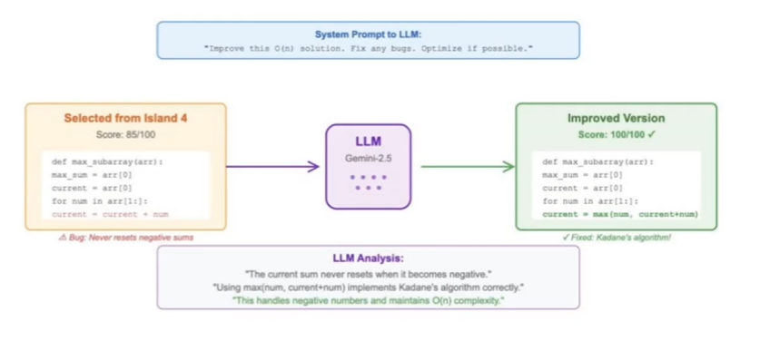
Figure 4.24: This figure shows why the usage of LLM works well when working with dynamic algorithms that need to evolve over time. Not only did it find a solution of O(n) runtime, but it also works to improve it.

In this case OpenEvolve did catch a big component where you are able to reset on 0. Hence, Kadane’s Algorithm. This is a very important part of OpenEvolve when trying to solve UCTP limitations.

4.3 UCTP integration to OpenEvolve
So now that we understand how OpenEvolve works and its strength, how do we integrate UCTP into this AI architecture? Knowing the limitations of UCTP, we understand that it has no benchmarks we can compare it to, its algorithms cannot evolve over time with new sensors being implemented into the satellites, and there is a big interest in having a real-time implication of Space Domain Awareness. We understand from previous chapters about UCT’s workflow of data generation and evaluation generation. We then feed that into a processor to understand how we can group uncorrelated tracks. OpenEvolve introduces a wide variety of solutions to optimize the workflows of UCTP.

The whole idea of the processor is trying to figure out the objects in a dataset. There are two main things that would be nice to optimize for the accuracy of the fit. As stated before, UCTP has metrics it takes account of when evaluating (state, residual, binary). These are all just different algorithms on trying to create a dataset based off of different equations used to find how accurate our Candidate orbits are versus our Reference orbits. We can use OpenEvolve to optimize these workflows. Alongside looking further into the future where UCTP can function in real time for new sensor suites. Where algorithms are able to evolve with new data and new approaches.

But this raises the question of how large and how computationally expensive this framework can get. If we look at UCTP workflows and pipelines, anything can become an island to optimize. The following questions need to be answered:
- Are we using OpenEvolve on a small-scale where we’re already mutating from already existing algorithms used by UCTP to optimize and find better algorithms.
- Are we using OpenEvolve on a larger scale where we have a dynamic benchmarking system between OpenEvolve and UCTP as new data comes in where the algorithm is always mutating?

These questions we asked to the sponsor. The current direction at the moment is solving OpenEvolve on a smaller scale for UCT processors. But looking at how complex UCTP is, it will become a lot larger in the future. Especially with the implementation of real-time UCTP where it evolves through time. On a smaller scale, our group has created a diagram showcasing how large the framework can get when integrating UCTP into OpenEvolve. This current idea is to pull the algorithms and equations used to evaluate the accuracy of Candidate Orbit versus Reference Orbit. Where each evaluation can be turned into an island:
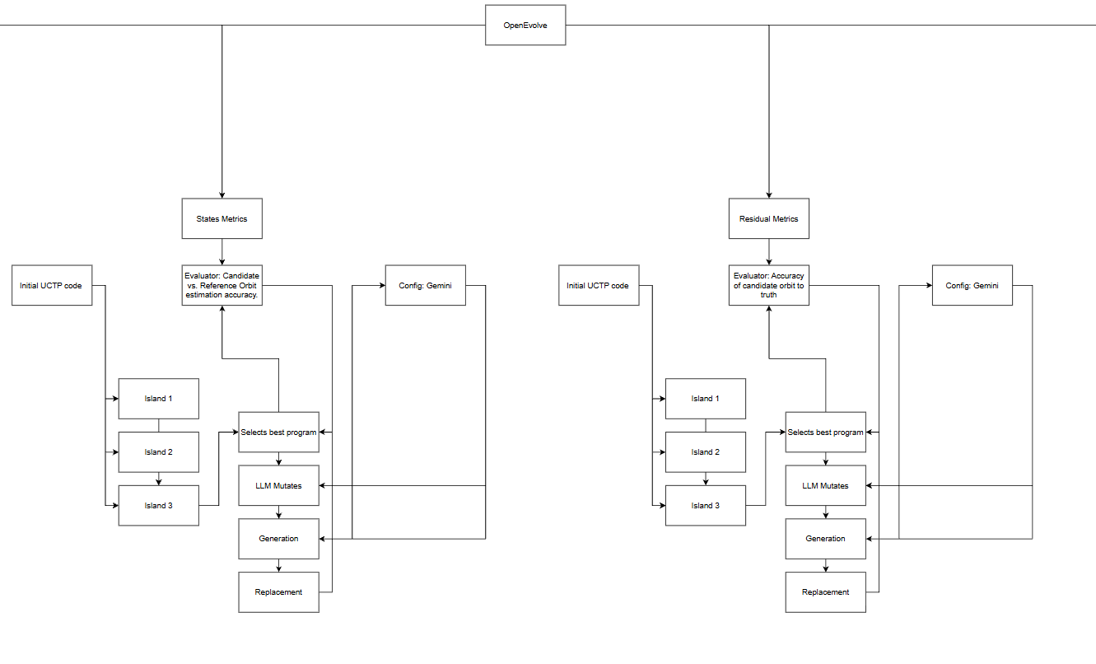
This UML diagram only shows two out of the four evaluation metrics that UCTP uses when creating the dataset. We also have to keep in mind that this is only the first part of UCTP where we were creating a dataset that the processor can handle. We also need to handle the benchmarking for UCTP. This proposes another big problem of the main reason we are using OpenEvolve. Which is to benchmark UCTP with a known solution. Does this mean that we would also need to integrate the processor portion of UCT and compare the solutions OpenEvolve generates to the current processor?

‘

Chapter 5. Symbolic Regression

5.1 Introduction
Understanding from previous chapters of UCTP and OpenEvolve, we know that we need to use OpenEvolve’s AI architecture to benchmark how well UCTP is performing and see if we can optimize workflows and pipelines. The idea of this section is to introduce the idea of symbolic regression. There are two main portions we are looking at in this topic, (1) LLM-SRBench which is a benchmarking framework for data driven scientific equation discovery. It integrates a pre-trained LLM with symbolic regression, evolutionary optimization, and parameter fitting, allowing it to infer underlying physical or mathematical relationships from raw data without prior knowledge of domain specific equations. (2) AlgoTune is a benchmarking tool for widely used mathematics, physics, and computer science functions. Its main goal is to try to answer if language models speed up general-purpose numerical programs. Alongside AlgoTuner which is an agent that enables language models to iteratively optimize code.

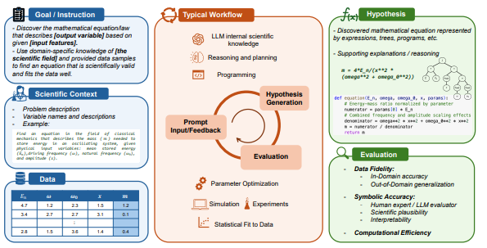
Figure 5.11: This figure showcases the overview of the LLM-based Scientific Equation Discovery used in LLM-SRBench. The blue (left side) section are benchmark tasks that combine scientific context with numerical data. The orange (middle) section is the discovery process that iteratively leverages LLM. The green (right side) section are the discovered hypotheses, represented as equation strings, trees, and programs.

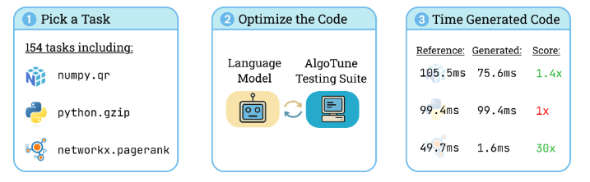
Figure 5.12: This figure showcases the overview of AlgoTuner agent that enables language models to iteratively optimize the code.

So why are these benchmarking tools important and how do they help us solve our problem with UCTP? To give a brief high-level explanation of these benchmarking tools:

LLM-SRBench: The idea of this science and research is that there is too much optimism around LLM based scientific equation discovery. When a lot of time they are memorizing famous formulas. This current benchmarking tool makes it impossible to memorize such equations when making discoveries on their own. Which is discovered that even with the best systems, it is still pretty bad. This benchmarking tool has 238 scientific domain problems (4 domains: Chemistry, Biology, Physics, Materials Science), and it splits it into two categories:
1. LSR-Transform (111 problems): Transforms known equations into uncommon but equivalent mathematical forms.
2. LSR-Synth (128 problems): Synthetic but realistic problems that mix known standard terms with novel, synthetic terms that are unlikely to be memorized.

AlgoTune: Is the same idea of LLM-SRBench. Where can a model write code that produces that same outputs as Python libraries used to solve scientific problems. But instead of focusing on scientific equation discovery like LLMSR-Bench, it focuses more on the performance optimization of numerical programs. Consequently, AlgoTune collects coding problems from real-world numerical libraries (NumPy, SciPy, scikit-learn, etc.). AlgoTune focuses on two things:
1. Benchmarking (154 problems): Numerical/ scientific programming tasks where the goal isn’t just to get the answer correct but more of an emphasis on how can we get the right answer the fastest?
2. AlgoTuner (agent): A loop around an LLM that manipulates, runs, and profiles code for the fastest accurate answers.

We talk a lot about these benchmarking tools, but when does symbolic regression come to play and what is it? Symbolic regression is the basic idea of given data, can we find a formula that’s generated it, and not just using a numerical fit. It is similar to how machine learning algorithms work, where we have a large sum amount of data and how can we make sense of that data through algorithms and patterns. So how is symbolic regression normal from regular regression? Regular or Ordinary Regression usually comes into a form of Linear Regression/Polynomial Regression where we have a form we can choose and then we fit the parameters based off of that. In Symbolic Regression we don’t assume a form. The algorithm searches over possible structures and then fits the parameters based off of that.

So, understanding that, we can see how OpenEvolve and these benchmarking tools come to play. Where we can use genetic programming / evolutionary algorithms to start from random formulas and mutate / crossover them. The idea of these benchmarking tools is to showcase the existing problems to this solution. Where in most cases when doing classical symbolic regression, the process usually goes as follows:
- Scientists pick ground-truth equations from any scientific domains
- They simulate data from those equations
- Then that data gets fed into the algorithm and sees if they can rediscover the original equation.

In a pre-LLM world this is fine because there is no risk of memorization. We have to understand that
LLMs aren’t blank states. They are pretrained from the internet, papers, code, etc. So, what is the idea of symbolic regression?
- Benchmarks for symbolic regression define their ground truth using already-known equations
- With LLMs, those same benchmarks become contaminated by pretrained data
- We need to define why symbolic regression needs to break memorization to remove leakage and force methods to actually do data-driven discovery and reasoning and not just recall.

So, in the following topics, we can go into a deeper dive of symbolic regression. To really understand how it works and the process of why it is important to solve UCTP limitations.

5.2 Foundation
Goal: build a baseline equation discovery. A type of machine learning algorithm; predict y given x. Searches for a mathematical equation that best fits a given dataset. Instead of just learning numbers (like linear regression) it tries to discover both the form and parameters of the equation. Symbolic Regression algorithm generates random combinations of math operations, constants, and variables, evaluates fitness where each equation is tested on your dataset. So, the closer its prediction is to the higher its fitness score.
It then takes the crossover where two good equations are selected and the parts of their structure combining genetic material:
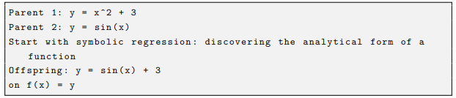
Figure 5.21: This figure showcases how we use symbolic regression to discover the equation of the function.

Represent equations as binary trees of mathematical operators (+, -, /, *, sin, etc). Apply genetic programming to evolve equations — mutate operators, and crossovers between good equations, and score each on dataset fitness. Fitness is measured with Mean Squared Error between the predicted and true outputs.

Maintaining interpretability: in machine learning means designing or choosing models that remain understandable to humans, so that we can explain why a model makes a certain prediction, not just what the prediction is.

5.3 Expected Results
Baseline SR achieves interpretability but limited exploration efficiency due to random search over a large equation space. LLM-SR Guided Equation Generation
Goal: Replace brute-force symbolic regression search with LLM-based hypothesis generation.
By using a pre-trained LLM (πθ) we can generate equation program skeletons, such as:
Figure 5.31: This figure showcases how we use symbolic regression to discover the equation of the function.

$F$ is the set of all the sampled equations. The notation $f ∼ πθ$ means each f is drawn from the model. This will continue to generate multiple functions and store into a dataset $D = \{(x_{i}, y_{i})\}.$ Then we use:
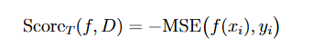

Which will keep the highest scoring equation and discard invalid or non-executable ones. Aims to maximize the reward ${Score}_{T} (f, D)$ for a given scientific problem $T$ and dataset $D$:
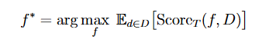

After each equation is generated, they test how well it fits the data $D$. The score is a fitness measure (measured with negative mean squared error $(-MSE)$between the predicted and actual data points). Higher score = better match to real data. Trying to find the equation that gives the best fit to the dataset. It will also use interpretation, so if the prompt mentions $”oscillator”$ it will generate $(sin/cos/exponential)$ terms rather than random operators, which will drastically reduce the combinatorial search space compared to the symbolic regression approach. For a given scientific problem $T$ and dataset $D$:

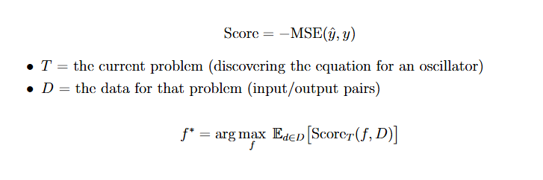

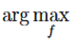
Finds the equation $f^{*}$ that achieves the best average score across the dataset. $E_{d}$ means average over all data points in D. the function$f$ that gives the highest score. Overview: The LLM $(πθ)$ is repeatedly asked to generate possible equation templates and each generated equation is tested on the real data, scored based on how accurate it is, and the process repeats until it finds the equation $f$ that best matches the data for that scientific problem.

Summary: Navigates through search space more efficiently and discovers more accurate equations with better out-of-domain generalization. Traditional symbolic regression uses search heuristics (genetic algorithms, reinforcement learning, or random sampling). These methods do not know physics, math, or domain logic, they just try operators until something fits the data. LLM-SR changes that by adding an LLM that already understands math structure, physics, and code syntax. It navigates the search space more efficiently. Traditional methods treat equation discovery as blind search, where each equation is a random combination of operators and constants, and they evaluate millions of times to find one good fit.

5.4 Hypothesis Generation
Goal: Leveraging a pre-trained LLM to automatically propose diverse and scientifically meaningful equation skeletons by acting as a hypothesis engine. It will propose new mathematical functions $def f(x, params):$ using context, problem descriptions, and evaluation instructions to produce an interpretable orbital model.

What the Prompt Needs:
- Instruction: Directs the LLM to complete the function so that it reflects physical meanings and relationships among input variables. Tells the LLM how to write the equation.
- Problem Specification: Gives context about what problem it’s solving, includes key variables, constraints, and objectives. Example: “model an oscillator using position xpos, ypos, zpos, xvel, yvel, zvel.”
- Evaluation and Optimization Function: Explains how the generated equations will be judged (e.g., scored based on MSE). This helps it produce structures that are measurable and testable.
- Experience Demonstration: Gives examples of previous good equations, showing what a successful equation looks like and how it improved in past rounds. This lets the LLM learn from proper attempts without retraining.

5.5 Sampling and Validation Process
At each iteration $t$, the LLM-SR will generate a batch of candidate question skeletons for diverse hypothesis exploration by adjusting temperature:
- Higher temperature → more creative, random outputs.
- Lower temperature → safer, deterministic outputs.
Tune to get a good balance of new ideas and sensible ones. Sampled equation programs are executed, and those failing to execute or exceeding a maximum execution time threshold are discarded.
Once the LLM writes code, it gets tested. If it crashes (syntax error, undefined variable) or takes too long, it’s thrown out. Only valid runnable equations move to the next stage where they’ll be tested on data.
The LLM’s in-context learning and crossover capabilities are employed to refine the suggested equation skeletons iteratively.
By representing equations as Python programs, we take advantage of the LLM’s ability to generate structured, executable code while providing a flexible and effective way to represent general mathematical relations.
The program representation also facilitates direct and differentiable parameter optimization to better optimize the coefficients or constants in the generated equations.

5.6 Optimization and Scoring
Goal: To adjust the parameter vector, params, to minimize the prediction error using Mean Squared Error loss function.
- NumPy and BFGS (scipy.optimize): A nonlinear optimization algorithm that uses gradients to find a local minima. It is effective for smooth, continuous functions and problems with relatively few parameters.
- PyTorch + Adam (torch.optim): A stochastic gradient-based optimizer to handle large or noisy datasets.
- BFGS (Broyden Fletcher Goldfarb Shannon): provides accurate deterministic fitting ideal for smaller problems with fewer parameters. Adam combines flexibility and scalability, which is good for noisy or high-dimensional data.

An optimizer uses gradient descent of a loss function to know which direction to move the parameters. “Stochastic” means random, in optimization, it refers to updating parameters using a random subset of the data rather than the entire dataset. The randomness helps make training faster, escape local minima, and introduce exploration in optimization.
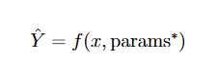
After optimizing the skeleton parameters, we assess the fitness of the equation hypothesis by measuring its ability to capture underlying patterns in the data. We compute predicted target values such as:

The fitness evaluation score$s$ is then calculated as the negative mean squared error between predicted and true target values. Mean squared error is a loss we want to minimize — lower MSE means a better model, and the higher MSE means worse. But in search-based or reinforcement learning frameworks, we maximize a score (reward), not minimize a loss.
This is defined as:
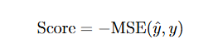
This flips the direction of optimization ,—, if MSE is small (good), s becomes a large negative number (closer to zero, higher). If MSE is large (bad), s becomes a more negative number (lower).

5.7 Data Generation
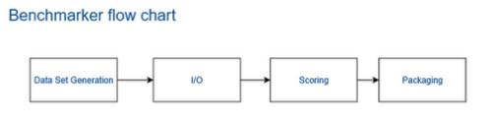
Figure 5.71: This figure showcases how UCTP generates data files to feed into the processor.

Test datasets are created based on the equation-based output (e.g., predicted orbital positions, velocities, or observed data) formatted according to the Unified Data Library schema to ensure compatibility with the UCTP processor.
- The I/O: This is generated and transferred into the UCTP benchmark system through standardized I/O operations. This is where we will store the JSON structure that contains observational and reference information to be scored accurately.
- Scoring: Compare with the truth dataset and compute performance metrics to quantify how well the LLM-SR generated equation explains or predicts observed data.
- Packaging: Export as a JSON and summarize into a report for detailed analysis. This validates the LLM-SR’s discovered equations against the UCTP standardized benchmarking framework.

Plausible Orbit Example from UCT:
- Uses the observations from the dataset_obs
- Produces a 6D state vector that makes sense (position (physically possible)) and velocity (physically realistic))
- The estimated orbit must have a realistic speed for a satellite if it’s in Earth’s orbit.
- How far is the candidate (predicted) orbit from the reference (true) orbit (in all 6 dimensions)
- Fits the noise measurement

To connect the sparse/noisy observations into one consistent orbit
- When you have a bunch of observations that are sparse (not many, maybe far apart in time) or noisy (each one is a bit wrong) and you want one consistent orbit (one 6D state + covariance) that explains them all.
  - The system will do this in two main steps:
    - Association: decide which observation belongs to the same object, how will it do this? It’ll look at the time, angles, and ranges. Motion must look like an orbit. Group observations that could be explained by one physically plausible trajectory. This will build “tracks” or “observations” groups where each group is treated as one object history. groupedObsIds in the dataset is the answer key for which observations belong to which true object.
    - Estimation: fit one orbit into those observations, despite noise and gaps. What Orbit will best explain this group? Well once a group has a group of observations {z1, z2, … zn} believed to be from the same object it starts with an initial guess of the orbit (a rough 6D state + epoch). Propagates that orbit forward/backward in time to each observation time. For each observation, it computes a residual (error) $({Residual }_{error}= z_{i}^{observed} - z_{i}^{predicted from orbit}).$ It will then adjusts the orbit to reduce the residuals overall (Least-squares/Kalman). Basically, finds all the 6D state that when propagated comes closest to all the observed points, even if there are few points (sparse), each point has error (noise). Sparse will use the model (orbit equations) to bridge the gaps in time. Noisy will use statistics (least-squares, covariance; to average out the errors)

5.8 Testing and Evaluation
Each team member completed evaluation logs from running the symbolic regression benchmark for the physical oscillator problem. This evaluation script tests the generated symbolic equation within initial program.py against the ground-truth dataset (X train for eval.npy and y train for eval.npy) to assess how well the discovered function models the target dynamics. In terms of what the model expected:
• 3 input variables
• 10 tunable parameters to be optimized during evaluation
• Loading input and output training data

Evaluation Results:
• Combined score: 1.6927 → this is the overall metric combining accuracy and interpretability, where higher values represent better performance.
• Negative mse: -0.0203 → this number represents the negative MSE between predicted and true outputs; since it’s closer to zero, it indicates higher accuracy.

Overview: Since we generated predictions with a low error rate, we can conclude that the model successfully suggests the discovered equation is both executable and reasonably accurate for this oscillator dataset. The evaluation module has correctly loaded, validated, and scored the generated equation structure using the defined scoring.
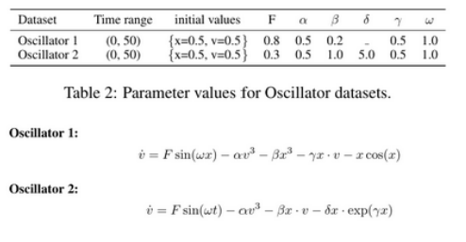
Figure 5.82: This figure showcases the parameter values for oscillator datasets.
5.9 Nonlinear Oscillator Equations
Nonlinear Oscillators are chosen to test whether the model can discover true physical relationships when evaluating and not just memorizing equations. Nonlinear equations can also involve non-convex optimization challenges and chaotic behaviors forcing the LLM-SR to reason symbolically about the equation under the hood. This is an important benchmark stress test, ensuring the algorithm can consistently discover accurate and interpretable equations, even when faced with highly complex or unstable dynamics.

6.0 Noise Robustness Analysis
To evaluate whether imperfect data conditions still work when dealing with real world settings we can conduct systematic analysis of model performance under varying levels of noise. To test this, we will use controlled Gaussian noise with different standard deviations (σ = {0,0.01,0.05,0.1}) to the training data. This analysis provides insight into how the incorporation of prior knowledge through LLM-SR affects equation discovery performance when dealing with noisy measurements.

For Example: Bell Curve.

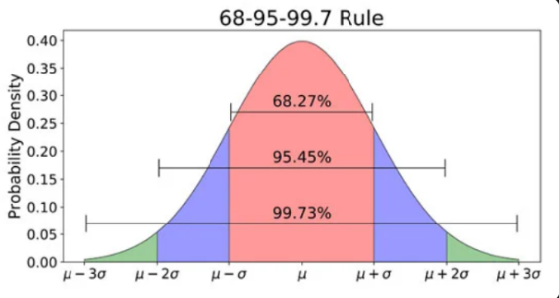

This highlights how data is spread around the mean (μ) based on the standard deviation (σ).
Each region represents how much of the data falls within certain ranges. The red region (central maximum) (68%) means that most measurements stay close to the mean. The blue region (95.45%) of all data points that come from this distribution. And the green region (99.7%) is the extremely rare distribution and rarely any points fall here. The height of the curve shows probability density (area under the curve corresponds to probability), so how likely values around that point are. Values near the mean (the center) are very likely and the sides of the chart have a low probability density, so extreme values are unlikely. We don’t know exactly how far away an object is, we want to define it as most likely a certain amount of distance away with a relative uncertainty of such and such amount. We want relative confidence that this thing is within an area of where we think it is. We are trying to encapsulate that with probability distribution. As we move further away there is a smaller chance that the object is further away than what you originally thought. The high standard deviation we would have a wider distribution. Skinny function (small variance), short function (large variance), so as we get further away there is still a high chance that the object is much further away than what we thought, whereas a small covariance there is a smaller chance that the object is further away than originally thought.
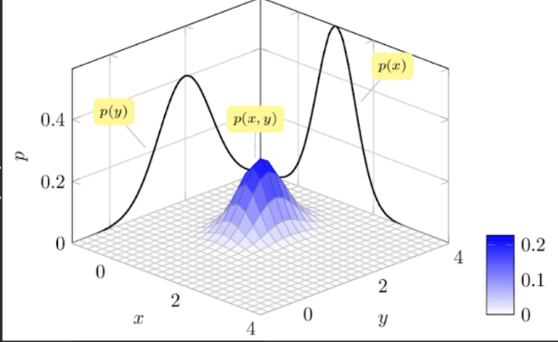
When we move to 2 dimensions, if we have an x and y component, we are now trying to find something in a 2-dimensional space instead of just how far it is along one line. In 1-dimension, we only asked, “how far is it?” but in 2-dimensions we now ask, “how far, and how far to the left or right?”. We can have the same probability distribution of the x-component and y-component so we will need two individual variances. There is also the possibility that if x and y are correlated (not completely independent) if every time y is positive x is also positive (and the same if negative) in addition to variances we also need cross-variance. These values define where the mean of the probability distribution is in 2-dimensional space, and the other three pieces of information (variance in x, variance in y, covariance of x–y) and package that into a 2x2 matrix which is now called the covariance matrix. This is going to tell us the same information of the 1-dimension (how uncertain are we about where this thing actually is relative to where we thought it is), now we are using more information like how uncertain are we in each direction and also how uncertain are we if its slightly in front then its also off to the left whereas if its behind than its to the right. There is less of a probability that if it’s behind it will be to the left. This is what covariance is telling us.
In 6-dimensions where we have 3 positions and 3 velocities, now we have a 6x6 covariance matrix, that’s telling us about the variance in each one of those 6 components and telling us how each one of those components might be related to each one of the other components. So, using this information we can fully define the probability of the distribution of where we think the object will most likely be. But also, what is the possibility that the object is slightly displaced from where we thought it was.
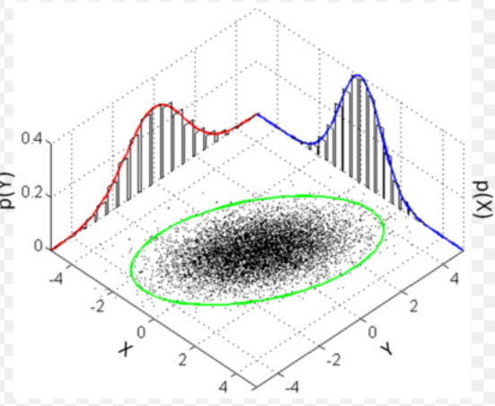
What we should be thinking about is what other questions we will need to ask to start thinking in the 6-dimensional state. So, if we took thousands different measurements of something, they are not going to be the exact same value (just about the same with small differences) there will be random fluctuations in our detector (noise or random effects) so we get a probability distribution. If we get a bunch of measurements and try to measure the same thing a whole bunch of times, we will not get the same thing every time because of noise or some other form of uncertainty. If we get something that looks like this, we can define all of these data points by probability distribution. If we were to make one more measurement of whatever we are measuring, where will it be? We won’t know exactly where it is, but with relative uncertainty we can say the most likely place it will be, we take the average of all of them. The average distribution will be the most likely spot for it to be. The covariance will be telling us where it will be but how likely it will it be a little off from that spot. If we were to make what is the relative probability that it will be somewhere.
There will be some spread in the x-direction and the y-direction, which are the two variances. There is also the possibility that x and y are correlated. For example, if it is more likely that x and y are both positive at the same time than it is for x to be positive while y is negative, then x and y have a correlation. So, in addition to needing the variance in the x-direction and the variance in the y-direction, we also need the covariance between the x and y components, such as x-y component, x-z component, and z-y component. Covariance tells us how the two variables vary together, as opposed to how each varies individually. The same idea extends to higher dimensions. In 3D, we can have spread in the x-direction, y-direction, and z-direction, but we also have covariances for the x-y component, x-z component, and y-z component. As the number of dimensions increases, the covariance must capture all the pairwise relationships. The covariance describes how wide or narrow the distribution is, and how far the probability distribution extends before the probability drops off. To fully define all this uncertainty information, we need a matrix whose size depends on the dimensionality of the state vector we are working with. For a 2-dimensional vector, the covariance is a 2x2 matrix; for a 3-dimensional vector, it is a 3x3 matrix; and for a 6-dimensional orbit state vector, the covariance is a 6x6 matrix. So essentially, the covariance tells us not just how each dimension varies on its own, but how different dimensions vary together, and the full covariance matrix grows with the number of dimensions in the state.

The orbit is most likely near a particular state but with some probability of being in nearby orbits. Because of this uncertainty, the UCT processor output should give both a mean and covariance for each candidate orbit, and the reference dataset should also provide a mean and covariance for each input reference object. In addition to comparing only the mean state vectors, we can use the covariance to determine not just the difference in the means but also a statistical difference between the two probability distributions represented by their mean and covariance. The 6 parameters of the state vector completely define the orbit we are trying to estimate. The covariance for this 6-dimensional position and velocity vector is a 6x6 matrix that defines how uncertain we are about that estimated position and velocity; The covariance essentially represents the spread of where the object might be. The 6-dimentaionl position and velocity vector is the center of the distribution (the mean) and the covariance defines the region of highest probability around that mean. By specifying both the mean and covariance instead of just the mean alone, the UCT processor can represent that the orbit is most likely near the estimated state, with some probability of being in nearby orbits. So, each UCT processor output should include a mean and covariance for every candidate, and the reference dataset should include a mean and covariance for each reference object. This allows us to compute not only the difference in mean state vectors but also a statistical difference between the two probability distributions described by their mean and covariance.

Covariance has a central maximum and drops off on both sides, and the mean of the distribution is the average of every data point underneath that bell curve. The standard deviation (how far apart the gaps are) is related to the width of that bell curve. The standard deviation is the square root of the variance, 1D probability distribution. How confident are we that we
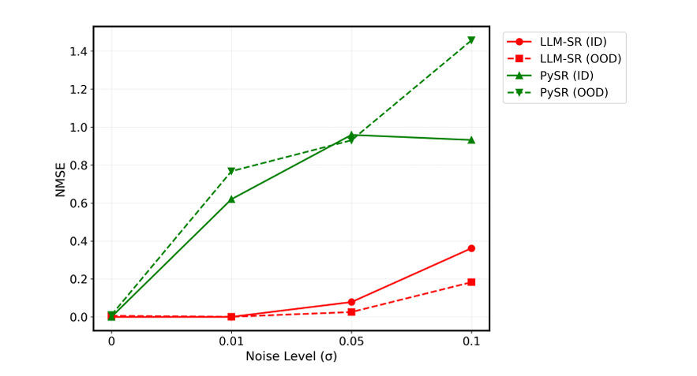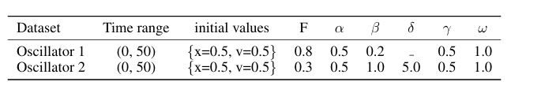
This plot analysis compares both LLM-SR and PySR on the Oscillation 2 benchmark. This shows normalized mean squared error for both in-domain (testing on data that comes from the same distribution as the training data) and out-of-domain (model is tested on data that is different from the training distribution) predictions under different levels of Gaussian noise. LLM-SR stays more robust out-of-domain, meaning that the test data is different from what it’s trained on, and it still works well. Where PySR’s errors increase with noise, PySR gets much worse when the data is nosier than what it was trained on. While all methods degrade in performance when noise increases LLM-SR exhibits better resilience compared to traditional approaches. This is because it uses physics/knowledge built into the prompts, this gives it physical intuition and helps it avoid nonsense equations. Therefore, it doesn’t get confused when the data is noisy. The domain knowledge limits the model to only search for realistic and physically meaningful equations. Focuses on what makes sense in your domain. So even with noisy data it finds good solutions. Which is why it’s robust. When the data gets worse the model will use prior knowledge and outperform those that don’t. So, with good data(clean), the model can rely mostly on the data itself. But with bad data (noisy or unreliable), the model must rely more on prior knowledge.

6.1 LLM-Based Optimization Baselines
There have been attempts to implement symbolic regression as an experimental task, as proof of concept. But their implementation lacked domain-specific knowledge, generating complete equations with LLM instead of optimizable skeletons, uses older LLM models, and lacks several design elements present in LLM-SR, such as equation-as-program representation and multi-island dynamic memory management (which is how we’re implementing it) for diverse exploration.
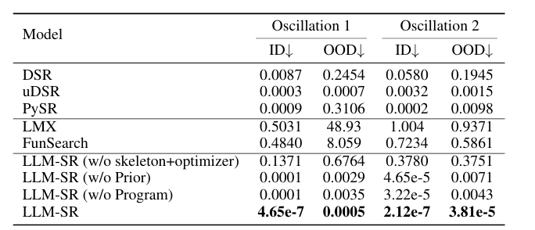
These results compare the different optimization approaches on two oscillator benchmarks. The metric they use to compare is NMSE (lower is better). As you can see, the traditional methods (DSR, uDSR, PySR) do okay on in-domain data but bad on out-of-domain data. LMX and FunSearch (LLM-based algorithmic search methods) both have poor performance, high errors. But LLM-SR is 10,000 times better than PySR, 1,000,00 times better than DSR, and about 1,000,000,000 times better than LMX.
Also noting that removing the skeleton code hurts the LLM-SR model drastically compared to just removing the prior knowledge or equation-as-program representation.

6.2 Summary
To fully grasp everything in this chapter, we started by understanding the OpenEvolve AI architecture and why Symbolic Regression is needed. We now know that to test whether or not the model is evolving and optimizing equation discovery so that we are then able to benchmark the UCTP to see if it produced better results. Our main goal is to ensure that the model is discovering the correct equations (e.g. mathematical/physics/computer science) and not memorizing famous formulas but instead building up ones for the best optimization based on the given code. We also introduced AlgoTune which is the engine of the entire LLM-SRBench, it's handling the performance optimization of numerical programs. But now we want to understand what Symbolic Regression is. The idea is that we are able to give it data and with little information it is able to discover the equation that generated that data. They define their ground truth using already-known equations. A scoring function is used to keep track of the highest scoring equation. After each equation is generated they test how well it fits with the dataset. The score is a fitness measure, higher score = better match to real data. Prompting becomes extremely important here since we want to be specific on how the model discovers these equations without creating anything useless. The prompt must include instruction, problem speciation, and evaluation and optimization function to propose meaningful skeletons. Adjusting the temperature allows us to get a mix of creativity and determinist outputs for new ideas. We want to train on random sets of data to make training faster, escape local minima, and introduce exploration in optimization by evaluating the score and calculating the negative mean squared error between the predicted and true target so that we reward the maximized score. Then by breaking down what we are receiving from the json file and understanding how to use that information is crucial for the next steps of this project as we start to think about how it'll be developed. We want to define and understand what kind of data the satellites are returning and what will be important enough to train the model and not confuse it with useless information. We also want to make sure that we are able to compile, test, and output information on sampled data from the OpenEvolve GitHub. This will help us understand any errors early on rather than dealing with them when it gets more serious. We also get a better idea of what OpenEvolve's processes is and how we can use that to implement in our own architecture. We understand that we need performance and accuracy when testing out the model’s evaluation results. The results are the error rates. Nonlinear oscillators are mentioned to ensure that the model is able to discover and evolve complex equations and stress test it for future high complex and dynamic systems. Then we move to bell curve and 6-dimensional implementation. First, we start of linear just to get a foundational understanding of what we should be asking ourselves as we move up in dimensions. From what we gathered we are using position and velocity to try and find an object’s specific point in time along its orbit. This is quite difficult, so therefore, the concept of covariance, mean, and standard deviation are introduced to explain that even if the position found isn't exact we can at least classify it with ranges and probabilities. As we moved to 2-dimensions we have to think about different movements (right/left) and distance (front/behind) and use that information to build off from 1-dimensional, which is why cross-variance is introduced, to grasp the idea of matrixes. It becomes harder to really know what questions you have to ask and what you need to think about when you are looking for something in a higher dimension. Those questions and ideas will have to be written down and researched. Also included information on controlling noise level and how that affects the LLM-SR and that it performs very well and is more robust when tested on data that is different from the training distribution. Lastly, include a few charts to show the high-performance rate LLM-SR has against other models

Chapter 6. Graphical User Interface (GUI)

6.1 Introduction
The analytic console is created in order to be able to keep track of OpenEvolve’s mutation to UCTP algorithms in real time. This analytic console also allows researchers to have an all-in-one dashboard where they are able to pull UCTP data from the output files and into OpenEvolve AI architecture. The user is also able to prompt a chatbot created within the dashboard to automatically generate evaluation metric codes from what the user specifies it to. This large language model is trained under OpenEvolve’s example problems that have been run and tested already. This allows a starting point for that chat bot to train on. Which is then also trained under the researchers using it in the future. So overtime the model gets better and more efficient at generating these evaluation files needed for the OpenEvolve Architecture.

6.2 OpenEvolve Architecture Versus Traditional Stacks
OpenEvolve already has a graphical user interface to showcase how the algorithms are evolving and so we are following that architecture and the tech stack to use so. The difference here is that instead of creating a web application where we need to host a server for a database. Everything will be held within the directory of the files being created and manipulated from each OpenEvolve iteration. The current tech stack that was identified from going over the visualizer python file embedded in OpenEvolve files are:

OpenEvolve Visualizer.py tech stack:
• JSON data creation and retrieval
• Python + Flask
• HTML/CSS/JSS

Environment:
• Real-time API scans per checkpoint
• All local based data not using a server since the High-Performance Computing cluster itself will be storing everything

The main problem of OpenEvolve’s architecture is the idea that we can’t have a consistency of how the metrics are per algorithm. What this means is that each different problem in OpenEvolve has their own schemas on the metrics that they use to evaluate how efficient OpenEvolve is doing. An example of this is that our sponsor wants a real-time line graph to show how OpenEvolve is doing so they can check up on the status of it and also identify when to stop the iterations. Since in some cases OpenEvolve finds the optimized code and solution fairly quickly even though you set the iteration bound to 100.

The next two figures will show how the different algorithms have different metrics. Talking to the sponsor, they wanted to be able to use this GUI in the future for other problems as well and one thing that was very beneficial from research that we gathered is the fact that we can make our dashboard dynamic. What we plan to do is we will loop through the metrics to find what is being evaluated to whatever algorithm we are using and then create the dashboard graphs from that. And so, our website will have dynamic sizing based off how many metrics are being used. The user will also have the ability to filter certain graphs(metrics) to their liking if they want to just focus on certain portions of the dashboard.

So how these are specified are:
Diversity and Complexity is provided per iteration, so we will just need to create a time series line chart to show the efficiency changes per iterations.

Some cases to look at are the feature_stats and the combined_score parametrics provided in the metadata.json.
- value_score: how close we got to the minima in function_minimization. (1.0 best possible result)
- distance_score: how far solution is in coordinate space from true optimum. (1.0 exactly optimum)
- combined_score: overall fitness combining value and distance. (combined_score=value_score+distance_score)
- reliability_score: consistency and robustness (1.0 all inputs tested are stable no failed states)

In the Metadata json file, this is how we will showcase in the dashboard of the dynamically created graphs based off each metric. The overall performance graph will be combined_score.

6.3 Analytic Console Integration
So now that we understand how OpenEvolve structures their evaluation, we can now try to integrate that with UCTP evaluation techniques. We are solely basing our evaluation file that we are developing in OpenEvolve based off of UCTP evaluation metrics as stated in Chapter 3. The following are UML diagram showcasing how we implement UCTP evaluation metrics into OpenEvolves AI architecture.

State Metrics:
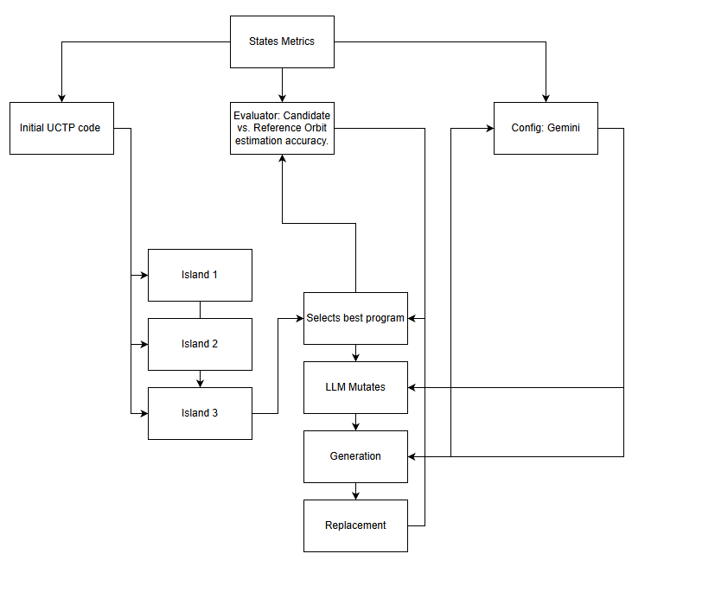
Residual Metrics:
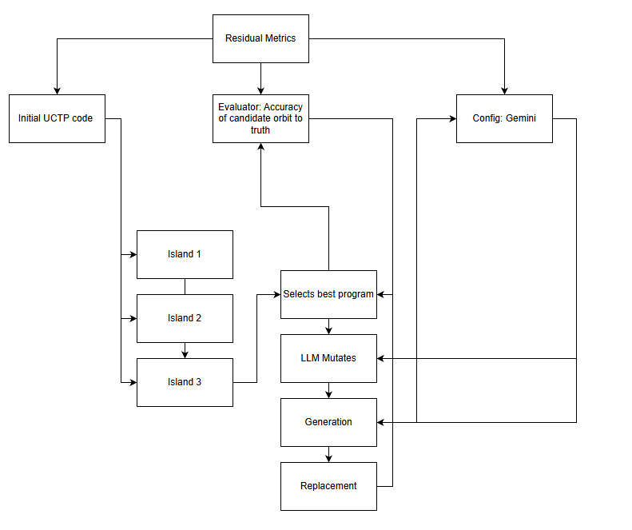

Binary Calculation Metrics:
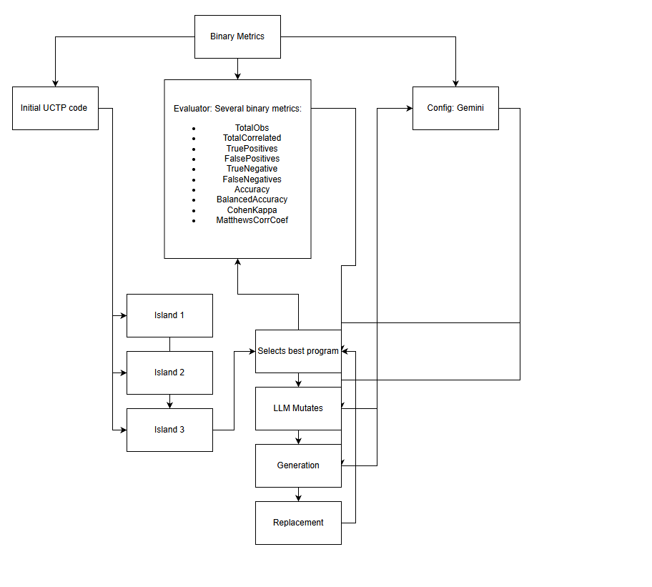
These UML diagrams showcase how each metric will be an island in OpenEvolve’s evolutionary process. Where is island has it’s own evolutionary loop of selecting the best program, mutating through LLM, generating a new and improved program, and replacing the worst.

Understanding OpenEvolve’s architecture, the Analytic Console will live within the directory of where you’re running OpenEvolve in. We don’t need a database like normal technology stacks because running OpenEvolve will be done through MITRE’s HPC. OpenEvolve also creates their own files in the directory that it is being run through, so in order to get real time updates, we will need to create a script that automatically checks the meta-JSON file in each iteration. This can be seen in figure 6.31 which shows the whole workflow of the Analytic Console.
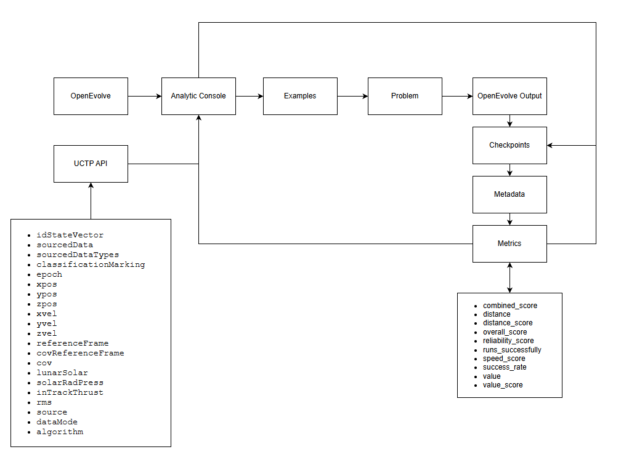
Figure 6.31: This figure showcases the flow of how the Analytic Console updates data from OpenEvolve in real time. The current Analytic Console doesn’t just do real time updates from OpenEvolve but also takes in data from UCTP as well so researchers have an all-in-one dashboard that showcases both sides of the problem.

6.4 Analytic Console Development
Currently, the Analytics Console has gone through two design iterations. We began with a simple dashboard only layout, but for usability and long-term vision the team added a dedicated home page and expanded the dashboard to display UCTP data. The graphical user interface design is now largely mature; the remaining work is to connect it to OpenEvolve so it can pull live data and validate the dashboard’s logic. Progress has paused for the moment, as development efforts are focused on integrating UCTP into OpenEvolve to enable meaningful end-to-end testing.

Design iteration no.1:
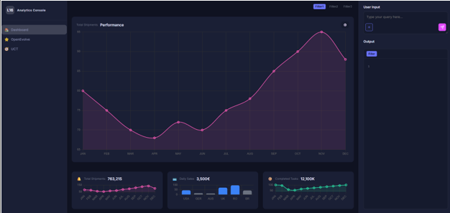

Final design iteration no.1 (Home Screen):
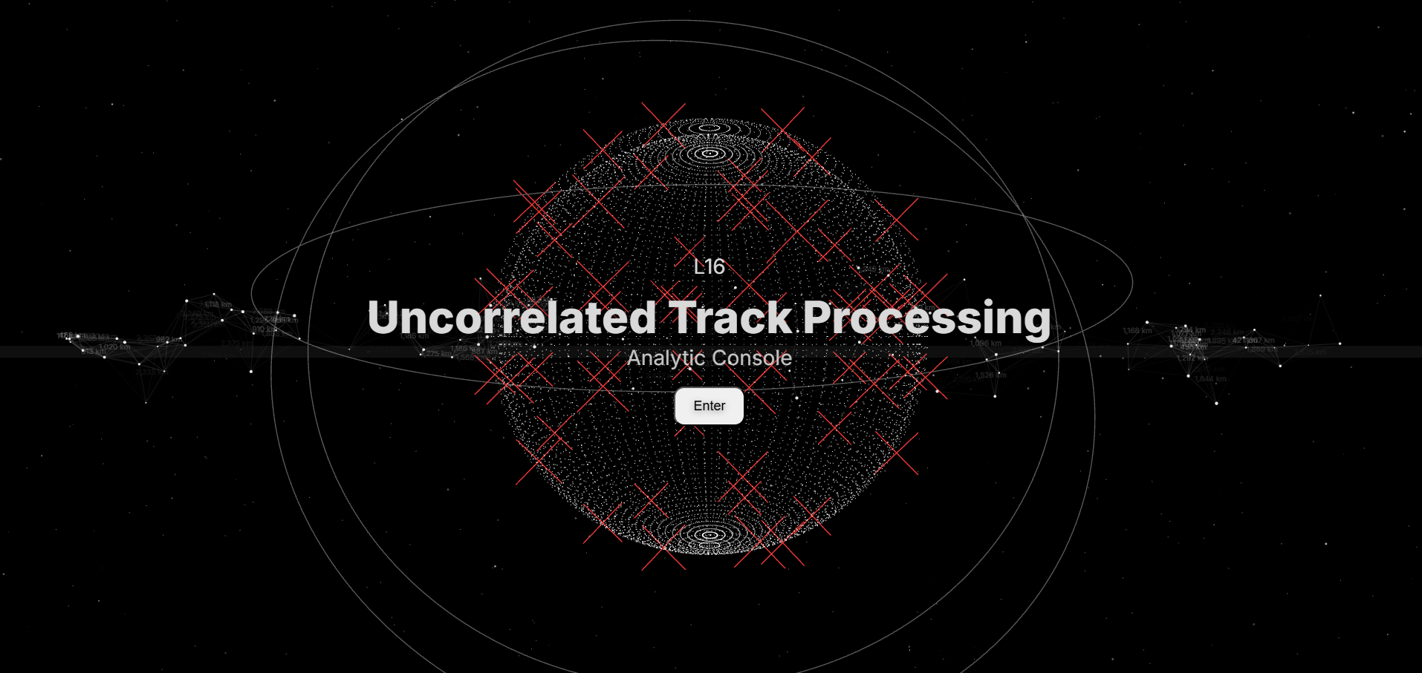

Final design iteration no.2 (Dashboard):
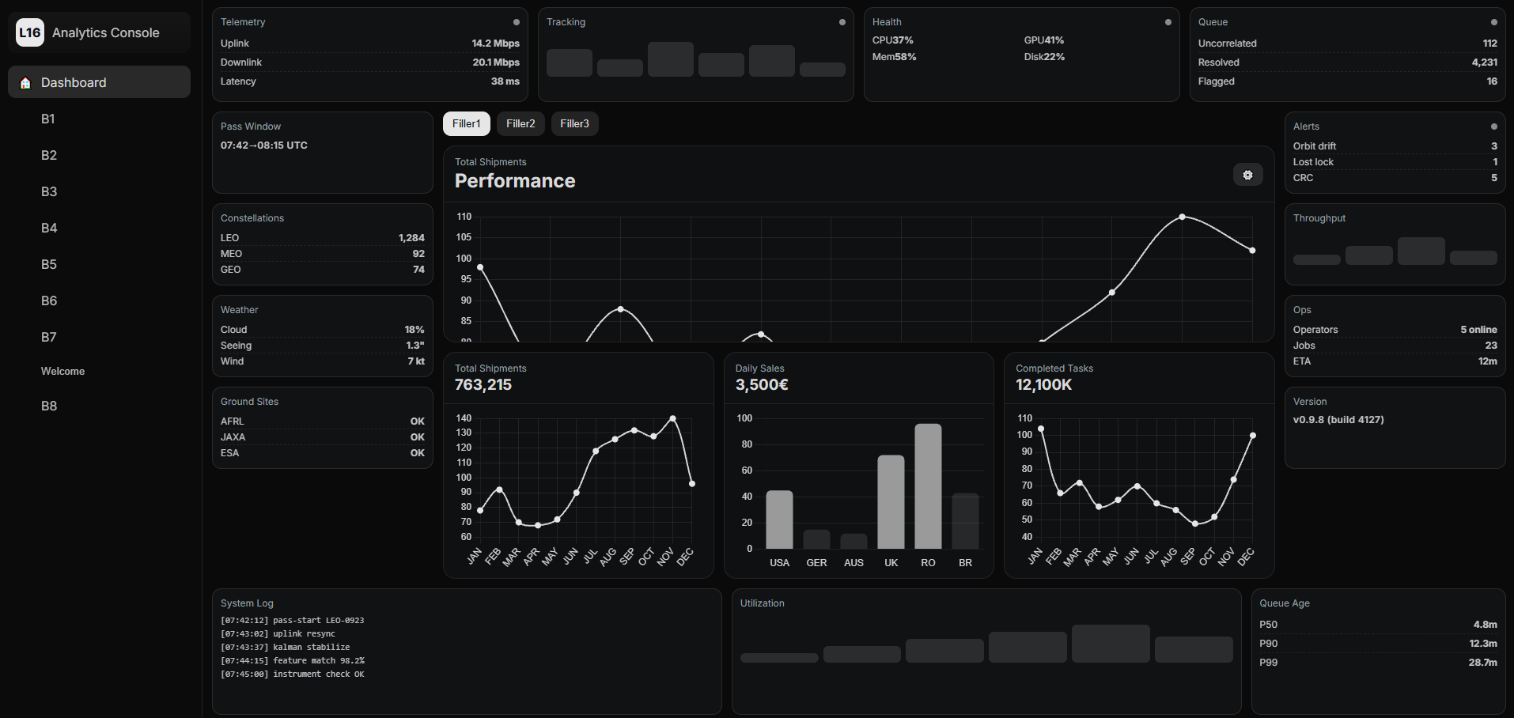

6.5 Future Development
Since the Analytics Console is ahead of schedule in terms of core functionality, the development team is taking the opportunity to incorporate more real world software engineering practices into the project. In particular, we plan to introduce Continuous Integration/Continuous Deployment (CI/CD) pipelines for the graphical user interface. These pipelines, implemented through GitHub, will run automated unit and integration tests on both the API and GUI to quickly detect whether any new changes break existing functionality or degrade performance.

These efforts are currently considered stretch goals, but they align with our long-term vision of making the Console maintainable and production ready. In addition, we aim to experiment with environment testing using containerized development setups, potentially orchestrated with Kubernetes. This would allow team members—and eventually sponsors—to spin up consistent, isolated environments for development and testing, improving reproducibility and easing future handoffs or scaling.
6.6 OpenOnDemand
OpenOnDemand provides a web-based way for us to access MITRE’s supercomputers (HPC resources). One of the main challenges in using these systems is maintaining consistency across all the software environments—things like Python versions, installed packages, and file layouts. To address this, our GitHub repository serves as a centralized development space for both the GUI and the LLM components. While each researcher still has their own local OpenEvolve setup for experimentation and documentation, the shared repository ensures that the code we intend to run on the HPC is developed against a common, agreed-upon structure.

A major blocker for the project right now is obtaining and working within MITRE’s HPC environment, which has strict licensing and software constraints. As a result, we can continue developing and testing the GUI on our personal machines, but we cannot yet guarantee that everything will behave identically on their systems. To close this gap, Dr. Cline (Senior Researcher at MITRE and SDA TAP Lab) and the team are exploring the use of Docker. By containerizing our environment, we can match the specific software stack allowed on the HPC and test our code in a controlled, reproducible way. The goal is to make the transition from our GitHub-based development to running on MITRE’s HPC as seamless as possible, like running example problems locally from the command line, but now encapsulated within a Docker workflow.

Chapter 8. GitHub Environment and Documentation

8.1 Overview
This section of the document serves to walk through the GitHub environment that all the researchers are working on. This environment is accessible to the public alongside additional contributors from sponsors and scientists we are working with. All code serves for transparency towards Space Domain Awareness. The following link is provided:
Project Code
Figure 8.11: These links are connected to both GitHubs being used. First one being Project which is a link to publicly available UCTP evaluator code. Second one being the Code which is a link to the following GitHub environment being shown in this section of the document.

This section also serves those in the future who will continue to work towards this effort for the integration of OpenEvolve’s AI architecture onto uncorrelated track processing.

8.2 Documentation Finalization Overview
Currently, our documentation is managed primarily through GitHub and slide decks. Within our GitHub repository, we maintain a custom LaTeX template that we designed to keep all written materials consistent, professional, and easy to update. Most of our formal write-ups and technical findings are produced using this template, alongside supporting analyses developed in Jupyter Notebooks.
In addition, all of our presentation slides are version-controlled and stored in the same GitHub repository. These slides capture what we present during our weekly sponsor meetings and serve as a chronological record of our progress, design decisions, and key results. Together, the LaTeX documents, slides, and additional documents form a unified digital footprint of the project, making it easier for team members, sponsors, and future collaborators to trace how our work has evolved over time throughout the scope of the project.
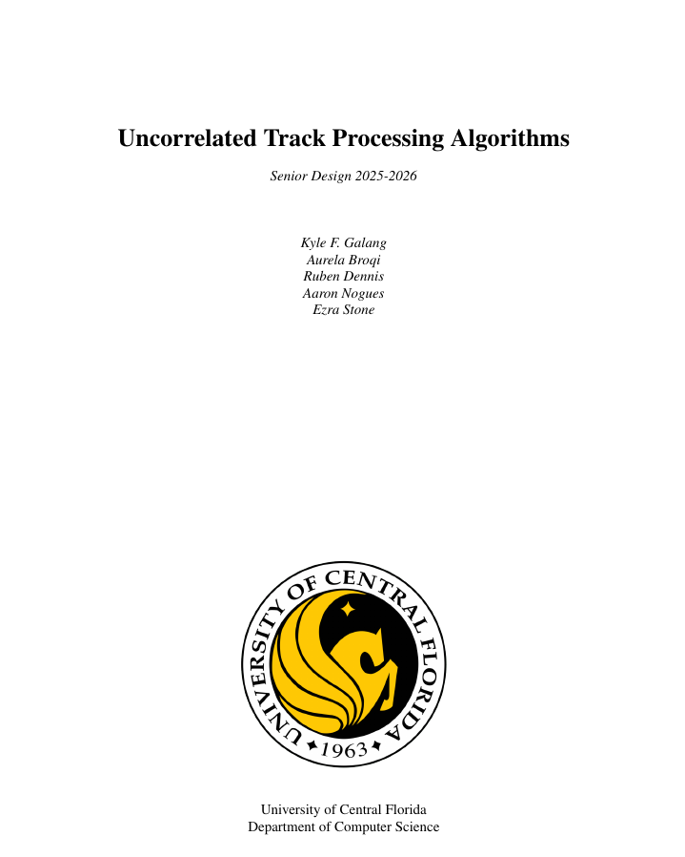
Figure 8.21: This figure showcases the LaTex template the group created to summarize a professional document for our findings.
8.3 Research Finalization Overview
Each team member has installed OpenEvolve on their local machine so they can independently experiment, track progress, and modify files as needed. To avoid losing work and to keep our changes synchronized, we also push our environments and key configuration files to GitHub, giving us version control and an easy way to roll back if something breaks.

Because OpenEvolve’s architecture is fairly complex, even small edits to the evaluator or initial Python files can significantly affect how iterations are run and how metrics are computed. To better align the framework with our goals, we are developing our own subset of benchmark problems that more closely resemble UCT scenarios. Most of our file changes focus on customizing the symbolic regression problem definitions, allowing us to study and adapt OpenEvolve’s behavior for UCT-like use cases.

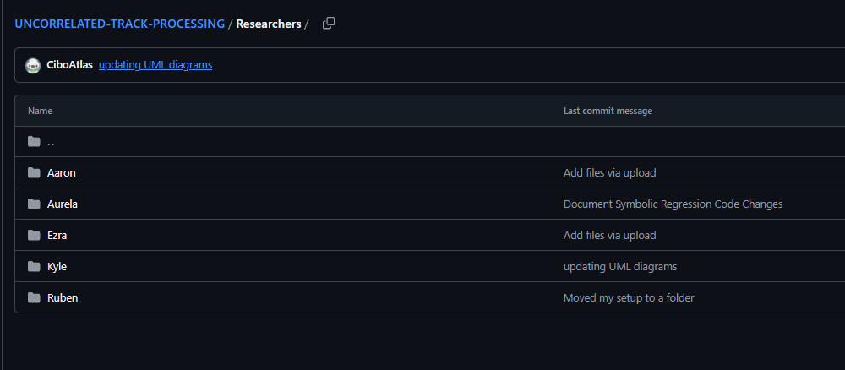
Figure 8.31: This figure showcases the different directories per researcher. This allows us to isolate our changes when developing our own approaches on how to integrate UCTP into OpenEvolve.

Figure 8.32: This figure showcases the OpenEvolve environment in each researcher’s directory. Of course, because we are uploading our OpenEvolve environments into GitHub, we also set up secrets which are basically environment variables for our OpenAI API keys.

8.4 Analytics Console Finalization Overview
The current state of the Analytics Console has changed a lot from the Figma design schematics shown in senior design 1. Many new features have been implemented onto the Analytics Console which will be gone over in this current section.


First, we must go over what data is being used in the Analytics Console alongside how it works:
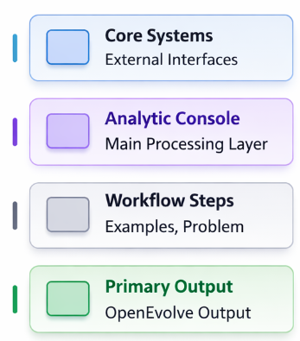
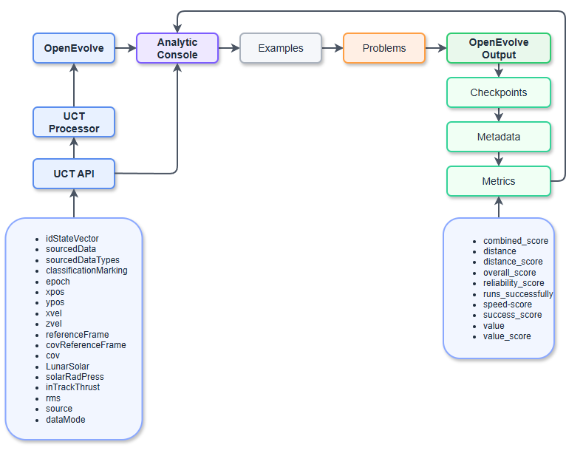

In the dashboard page, many different data types are being transmitted through.
- OpenEvolve’s Checkpoints: After each evolution OpenEvolve spits out the best programs and its metrics per checkpoint specified in the configuration and evaluation file. OpenEvolve writes checkpoint folders on disk, and each checkpoint contains a best_program_info.json file with iteration information and a metrics object. Every 10 seconds the backend scans those checkpoint folders. Sorts them by checkpoint/iteration order and normalizes the numeric values. Then it exposes that data through a REST-style endpoint. On the front end, the dashboard polls that endpoint, converts each metric into a time series where x is the current_iteration and y is the metric value, and feeds that into chart.js to render the graphs per metric specified by the evaluation file. The panels included by this data poll are Performance, Metric panels, Runs Successfully, and Graph. You will see if you are having errors in the system log terminal which gives updates to the API endpoints.
- UCT API: The dashboard also takes datasets from dummy data being used. This data can be found in the assets folder inside the UI-DEVELOPMENT folder. An example of this dummy data is the 1 object 1000 observation data. Which follows the UCT bench marker schematics. That data is also polled into the dashboard on the outer panels (Constellations, Telemetry, Queue, Alerts, Ops)
- OpenEvolve’s Configuration: The dashboard is able to reroute where the data is being taken from through the settings webpage. This is primarily for the configuration panel in the bottom left corner of the dashboard.
- OpenEvolve’s Log: The dashboard is also able to reroute this data. This data is automatically generated in OpenEvolve runs. These are the prompts the user usually sees in the terminal when OpenEvolve is running. But the dashboard is also able to take those updated logs and showcase them in the front end.

Design Choices:

8.5 mini–Large Language Model Finalization Overview
In our GitHub repository, we keep a central directory that holds a single, shared OpenEvolve environment managed by the development team. We set this up because, in our individual research directories, we frequently change variables, configuration files, and problem setups in OpenEvolve. To avoid breaking the core framework, we created a separate “single truth” environment: a clean, stable copy of OpenEvolve that we leave untouched for experiments.

Our goal for the GUI and LLM work is to eventually contribute them directly to the main OpenEvolve GitHub repository. The intention is that the GUI will act as an optional add-on, providing a user interface without modifying or interfering with OpenEvolve’s existing core code.

We have confirmed with our sponsors that the research we do with OpenEvolve can be made public, so we are free to share our methods, results, and tools and to contribute improvements back to the open-source project. The only pieces that must remain restricted are the UCT data and the specific UCT architecture we use. Our GitHub repository and Jira board are also shared with our sponsors, allowing them to follow our documentation, research progress, and tasking through the end of March.

